Simultaneous Quasi-Periodic Pulsations in Solar Flares and Terrestrial Ionosphere
Kostina P.V., Pilipenko V.A., Surkov V.V.https://orcid.org/0000-0003-3434-2466

Institute of Physics of the Earth, Moscow
Abstract
Quasi-periodic pulsations (QPPs) with periods from few seconds up to several tens of minutes are an inherent feature of solar flares. QPPs are observed in different flare electromagnetic emissions (from radio waves up to gamma-rays). Physical mechanisms responsible for the generation of QPPs are still uncertain. Here we present several events when QPP are observed simultaneously in flare emission and in total electron content of the terrestrial ionosphere. The Variational Mode Decomposition (VMD) method has been used to extract the main oscillatory mode from raw solar and ionospheric data. The revealed time delay of the ionospheric periodic response from solar QPP is probably caused by a finite time of recombination of the F-region plasma.
Keywords: solar flare, quasi-periodic pulsations, TEC of the ionosphere

Introduction: QPP and its impact on terrestrial ionosphere
Solar flares are the most powerful processes in the solar system and hence are subject to extensive studies. Often, solar flare light-curves exhibit oscillatory patterns, known as quasi-periodic pulsations (QPP) [Zimovets et al., 2021]. The typical periods range from a fraction of second to several minutes, and the modulation depth often reaches 100% [Hayes et al., 2019]. QPPs are a common and intrinsic flare phenomenon, therefore, their understanding is necessary from the standpoint of the fundamental physics of the astrophysical environment energy releases [Nakariakov and Melnikov, 2009]. QPPs have a significant seismological potential for the diagnostics of physical conditions in solar flaring regions, as oscillatory patterns of solar loops may even precede solar flare onset.
Solar flares release vast amounts of energy in extreme ultraviolet (EUV) and X‐ray emission, which can significantly increase electron density in Earth's ionosphere. While QPPs in solar flare emission have been observed for many years, their potential to induce similar behavior in the Earth's ionosphere has not been fully investigated and it remains unclear how sensitive the ionosphere is to small scale changes in solar flare EUV emission [O’Hare et al., 2025]. Flare emission occurring on the Earth‐facing side of the Sun can cause an increase in electron density in different layers of the Earth's ionosphere. X‐ray (<100 Å) and EUV (100–1000 Å) emission affect the entire dayside ionosphere, dramatically increasing the ionization and molecular dissociation of atmospheric components at different altitudes. Generally, in the E-layer softer X‐rays (10–100 Å) are primarily absorbed, while in the F‐layer EUV photons are the dominant source of ionization.
Total Electron Content (TEC) is defined as the total number of electrons integrated between two points along a tube of 1 m² cross-section. The remote sensing method for calculating TEC derived from the Global Navigation Satellite System (GNSS) has become a widely used tool for monitoring fluctuations in ionospheric electron density. The majority of the electron content in the ionosphere is concentrated in the most ionized F‐region, which is why EUV flare emission predominantly causes changes in TEC. The flare-induced perturbations affect the code and phase delays of the received GNSS signals.
Currently there are a number of multi-wavelength space missions (such as RHESSI, STEREO, Hinode) covering almost the entire range of electromagnetic emission, which are able to perform observations of flare regions with high temporal (up to fractions of seconds) and spatial (up to about one arc second) resolutions. In this study we examine how sensitive the ionosphere is to small scale changes in solar flare EUV emission.

Data sources and analysis technique
Spectral characteristic of solar photons is measured either in energy E (eV) or in wavelength λ (nm), related by the relationship E (eV) ≈ 1240/λ (nm). For our study the most important range is from extreme UV (10-100 nm), UV (100-400 nm), and to soft X-ray (<10 nm). γ-rays (>10 keV) are not considered. We have used the following databases for solar flare data: (1) EUV spectral irradiance observations recorded by the EVE instrument onboard the SDO satellite with a cadence of 60 s; (2) GOES data for shortwave (0.05-0.4 nm) and longwave (0.1-0.8 nm) wavebands; (3) STIX photon counts for separate channels (4 - 10 keV, 10 - 15 keV,15 - 25 keV, 25 - 50 keV, 50 - 84 keV); (4) the SOHO flux for two channels (26-34 nm and 0.1-50 nm). TEC values are calculated from GNSS data provided by NASA Earthdata and SOPAC databases.
The primary analysis of periodicity in ionospheric and solar radiation data consists of Lomb-Scargle periodogram computation and identification of the main oscillation period. This allows the detection of the target periodicity, since periodic components are not universally identifiable in all events, and a verification of period consistency for both solar flare and ionospheric response. Additionally, periodograms confirm the existence of periodic oscillations across various measurements (with a substantial part of TEC values from of GNSS stations having observable periodic component). This step proves that for the event in question the identified period is consistently manifested within individual components.
For a more detailed analysis of the oscillating component, it must be isolated from the main trend. Variational Mode Decomposition (VMD) method [Zosso and Dragomiretskiy, 2013] makes it possible to extract the main mode corresponding to the target periodic component. VMD is an adaptive non-recursive signal processing method designed to decompose complex, non-stationary, and nonlinear signals into a finite number of sub-signals or modes, known as Intrinsic Mode Functions. The comparison with periodograms provides an independent cross-check of the primary oscillation period, ensuring that the mode extracted isolates main analyzed oscillatory component. Subsequently, this specific mode with a period approximately consistent between the solar flare and ionospheric data is used for further analysis. Application of VMD method to each measurement in both datasets results in a set of periodic data components: time series for individual solar radiation measurements, alongside corresponding time series for deviation of TEC from background level - dTEC/dt at individual stations. The optimal selection results were found for 5-mode decomposition.
The obtained two sets of timeseries representing the solar flare and the subsequent ionospheric response enable a statistical comparison using pairwise cross-correlation analysis between solar and ionospheric timeseries. This opens a possibility for an assessment of the general parameters of the ionospheric response, as well as their variability due to differences in wavelengths (for solar radiation) and geographic locations (GNSS stations). The calculation of mean period over pairs of timeseries and comparison of correlations allows for a creation of a subset of pairs for solar-ionosphere data, in which both timeseries show main periodicity, and this subset is used for search of time lag between timeseries calculated via cross-correlation.
Figure 2. Map of GNSS stations used in the analysis of February 1, 2026 event
Figure 3. VMD analysis for solar flare and dTEC timeseries on February 1, 2026
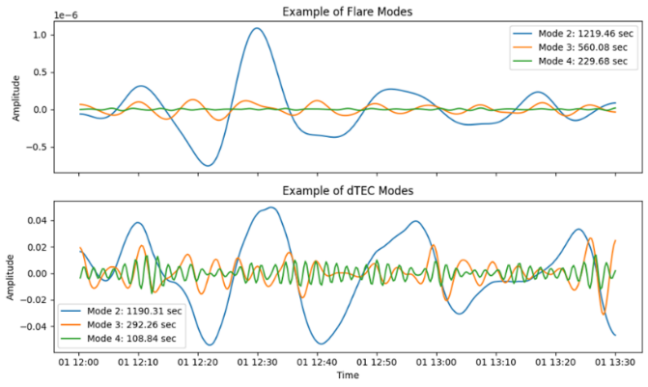
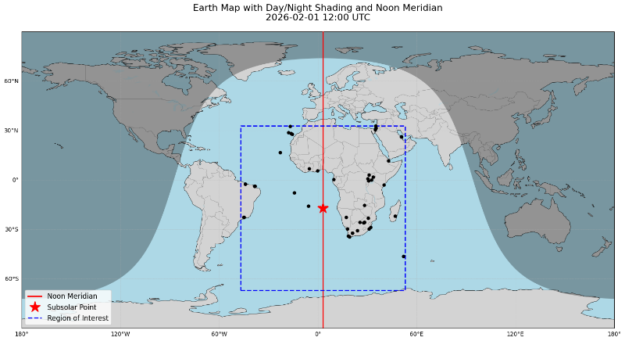
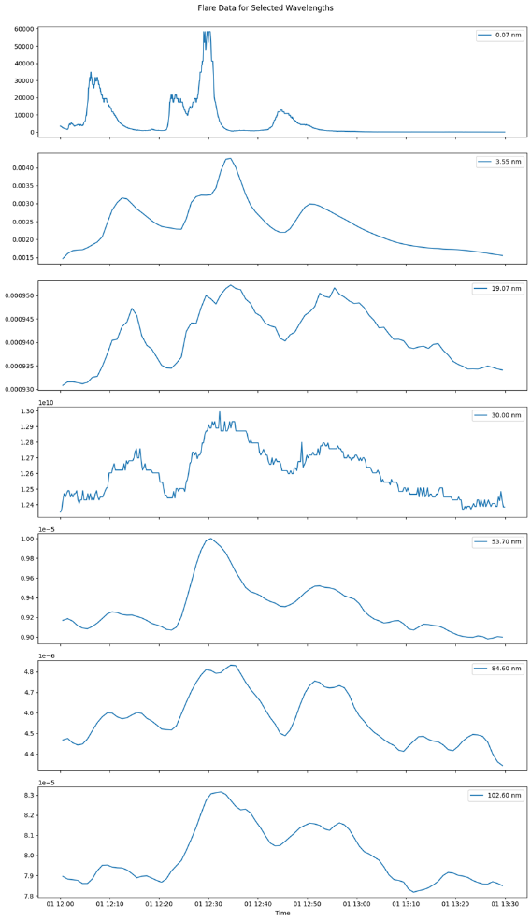
Figure 1. Solar flare emission in different wavebands recorded on February 1, 2026
February 1, 2026
The flare was observed between 12:00 and 13:10 UT on February 1, 2026. It consisted of three QPP variations of solar emission in X-ray to UV wavelengths (from 0.1 to 100 nm) as seen in multiple sets of solar irradiance data (Fig. 1). Based on the solar data, the period of the flare variations is T ~ 20 min. GNSS stations for TEC data are chosen from the dayside area on 12:00 UT (Fig. 2). For this event both solar flare and TEC periodograms (not shown) confirm visual estimation of period T~1300 s (22 min).
To reveal the main oscillating component the VMD method has been applied to the solar flare and ionospheric data (Fig. 3). Application of VMD method to each measurement in both datasets confirms the average period of pairs in a subset (~1220 s). The relative amplitude of the main mode as compared with background level (trend) is ~100% for solar flare, and ~30% for dTEC/dt.
For selected fundamental mode in solar and ionospheric data the cross-correlation analysis has been performed for the corresponding pairs (~600 samples). The average time lag between solar emission oscillations and dTEC/dt for this event was estimated to be ∆t~150 s, corresponding to delay of TEC variations as compared with solar emission variation by ~41º (Fig. 4).
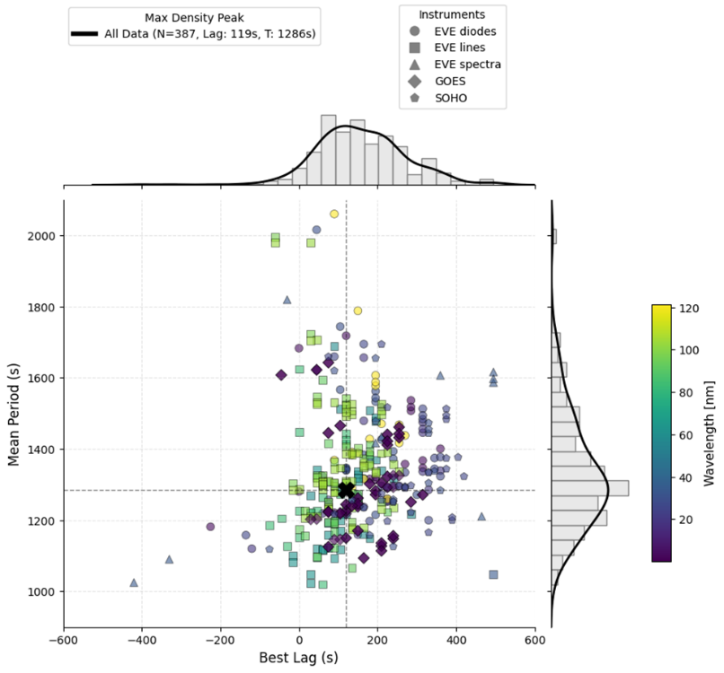
Figure 4. Results of the pairwise cross-correlation between averaged TEC response and solar emission intensity. Threshold cross-correlation coefficient Ro=0.5. The dashed lines denote the average period T≈1280s and time lag ∆t≈120s
May 5, 2015
For this event QPPs preceded the main impulse of the flare, and looked like a “precursor” of flare (Fig. 5). The interval for the analysis 20:30-22:00 UT contains three impulses of solar emission (Fig. 6). Period is estimated to be ~25 min (~1500s).
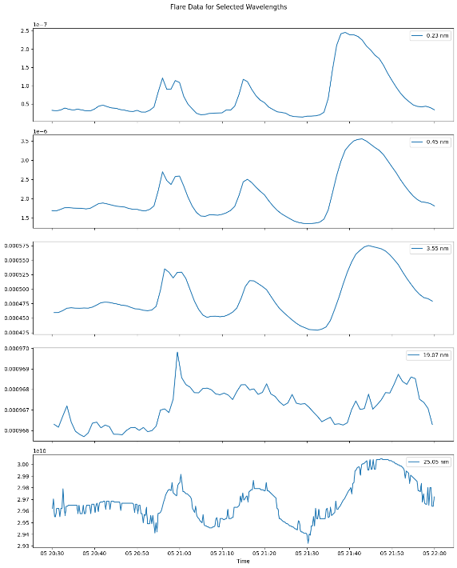
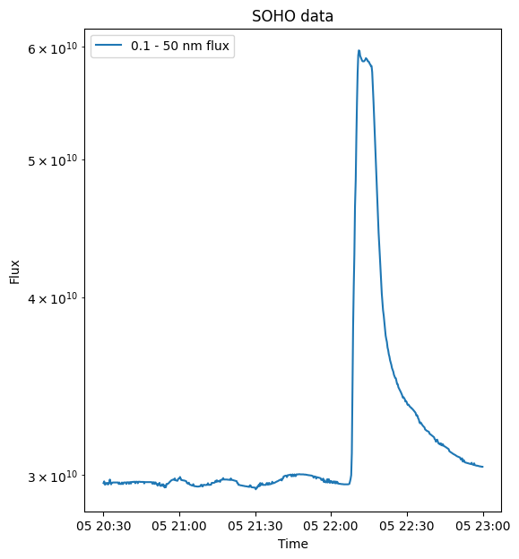
Periodogram analysis confirms visual estimate of period and provides the result for period being ~1500s (not shown). The main dTEC/dt mode is consistent with expected period from solar emission (Fig. 7). The relative amplitude of the main mode as compared with background level is ~5% for solar flare, and ~20% for dTEC/dt. The paired cross-correlation analysis shows a dominant positive time shift between datasets as ∆t~120 s, corresponding to delay of TEC variations as compared with solar emission variation by ~29º (Fig. 8)
Figure 6. Solar emission in different wavelengths before the flare onset on May 5, 2015
Figure 5. Solar flare with QPP “precursor”, May 5, 2015
Discussion and conclusion: Coupling between wave processes in the solar corona and terrestrial ionosphere
There is a great variety of flaring QPPs - from nearly monochromatic oscillations observed in the radio or EUV emissions up to irregular sequences of spikes observed in hard X-ray and microwave emissions. Most probably there are a number of principally distinct physical mechanisms responsible for different types of QPPs. Understanding periodic energy release provides us with a promising tool for contribution to solar flare forecasting. The world of ULF (ultra-low-frequency) wave processes is observed in the same frequency range as QPP in the near-Earth space. Solar flares accompanied by QPPs of electromagnetic emission can potentially be more geo-effective than flares without such QPPs due to possible resonances with the magnetospheric oscillations.
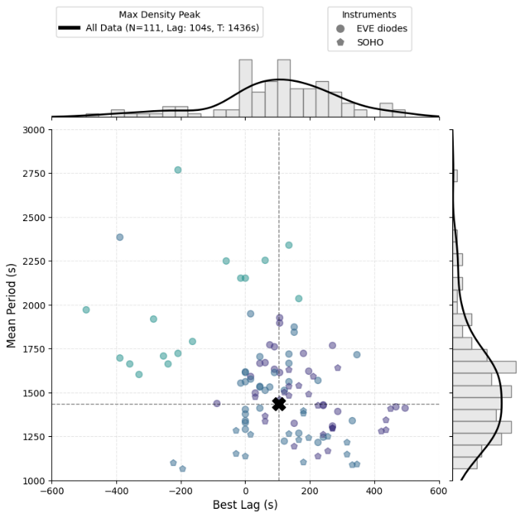
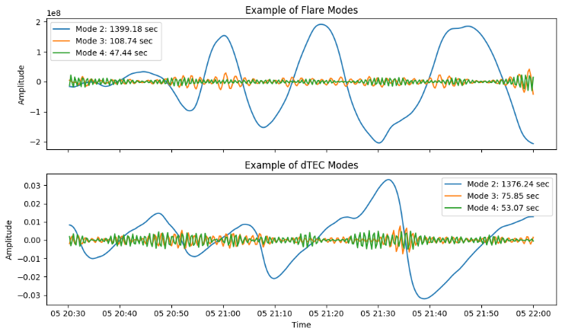
Here we presented examples showing that coupled periodic regimes can take place on the Sun and in the terrestrial ionosphere separated by ~150 million km. The applied VDM algorithm selected unambiguously the same main modes in these systems. The revealed time delay between solar QPP and ionospheric periodic response are probably caused by a finite time of recombination of the F-region plasma.
Figure 7. VMD analysis for solar flare and dTEC timeseries on May 5, 2025
Figure 8. Results of the pairwise cross-correlation between averaged TEC response and solar emission intensity. Threshold cross-correlation coefficient Ro=0.5. The dashed lines denote the average period T≈1440s and time lag ∆t≈105s

Financial support
This study is supported by the grant 25-27-00539 «Impact of solar flares on electromagnetic processes in the system atmosphere-ionosphere» from Russian Science Foundation.

References
Hayes L.A., P.T. Gallagher, B.R. Dennis, et al. (2019) Persistent quasi-periodic pulsations during a large X-class solar flare, Astrophysical Journal, DOI: 10.3847/1538-4357/ab0ca3
Nakariakov V.M. V.F. Melnikov (2009) Quasi-periodic pulsations in solar flares, Space Sci Rev 149, 119–151.
O’Hare A.N., Bekker S., Hayes L.A., Milligan R.O. (2025). Quasi-periodic pulsations in ionospheric TEC synchronized with solar flare EUV emission. J. Geophys. Res., 130, e2024JA033493.
Zimovets I.,·McLaughlin J., Srivastava A., et al. (2021) Quasi-periodic pulsations in solar and stellar flares: a review of underpinning physical mechanisms and their predicted observational signatures, Space Science Reviews 217:66.
Zosso D. Dragomiretskiy K. (2013). Variational mode decomposition. IEEE Transactions on Signal Processing. 62.

Связанные квазипериодические пульсации в солнечных вспышках и земной ионосфере
Костина П.В¹, Пилипенко В.А², Сурков В.В.³
¹Институт физики Земли РАН, Москва, kostina.pv@yandex.ru
²Институт физики Земли РАН, Москва, space.soliton@gmail.com
³Институт физики Земли РАН, Москва, surkovvadim@yandex.ru
Аннотация
Квазипериодические пульсации (КПП) с периодами от нескольких секунд до десятков минут являются неотъемлемыми свойствами солнечных вспышек и наблюдаются в различных диапазонах излучения солнечной вспышки (от радиоволн до гамма-лучей). Физические механизмы, отвечающие за создание КПП, до сих пор не вполне понятны.
В данной работе представлены события, в которых наблюдаются одновременные квазипериодические пульсации в солнечном излучении и полное электронное содержание (ПЭС) ионосферы Земли. Для извлечения основной осциллирующей моды из солнечных и ионосферных данных используется метод вариационного разложения на моды (Variational Mode Decomposition, VMD). Полученные результаты показывают наличие задержки ионосферного периодического отклика на квазипериодическую пульсацию солнечного излучения, основной причиной которой предполагается время рекомбинации плазмы F-слоя.

Ключевые слова: солнечная вспышка, квазипериодические пульсации, ПЭС ионосферы

