Extreme enhancements of the eastward electrojet

L.I. Gromova¹, N.G. Kleimenova², S.V. Gromov¹, L.M. Malysheva²
¹Pushkov Institute of Terrestrial Magnetism, Ionosphere, and Radio Wave Propagation, Moscow, Troitsk, Russiа;
e-mail:gromova@izmiran.ru
²Schmidt Institute Physics of the Earth RAS, Moscow, Russia

Abstract. The eastward electrojet is one of the important elements of the ionospheric currents associated with different magnetosphere disturbances. Here we studied the extreme eastward electrojet enhancements basing on their ground magnetic signature defined by AU index. The values of AU index higher ~ 900-1000 nT can be attributed to the extreme ones because they are almost twice as big as usual. We found only 18 such extremely strong AU events during 2000–2025 using 5-min data from the WDC Kyoto AE Index Portal. Our analysis of the space weather conditions in which these events were observed showed that they were recorded mostly during strong (|Dst_{max}| > 100 nT) magnetic storms. However, not every strong magnetic storm was accompanied by an extreme increase in the AU-index. It was found that extreme AU increases occurred only under the positive IMF By values during or after a long period of negative or close to zero IMF Bz values. The extreme AU increases could be observed in any phase of the magnetic storms but more often in the initial and main phases of the storm. In the initial storm phase, these AU events were relatively rare phenomena with a typical duration of about 2 h and association with jumps or very significant enhancements (up to ~70 - 80 nPa) of the solar wind dynamic pressure (Psw) under positive IMF By and negative IMF Bz. In the main storm phase, these events often represented the sequences of ~ 30 min AU bursts followed very strong (up to 50-60 nPa) bursts of the Psw and accompanied by fluctuations in IMF Bz and By. In the recovery storm phase, the very short (<30 min) bursts of the extreme AU increases were associated with abrupt changes of the direction or values of the IMF components observed under the rather strong ring current (SymH ~ −(120-150 nT)). The Psw values were not the determinant parameter. The details of the studied events during some strong magnetic storms are discussed.
1. Introduction
One important feature of the ionosphere E region represents the horizontal westward (WE) electrojet in the near midnight and dawn sector, and the eastward (EE) electrojet in the dusk sector. Their ground magnetic signature is known as negative and positive bays in the H-component of the magnetic field, and it is defined by the AL and AU indexes. Typically, the WE are located between the 67–69° MLAT while the EE is seen to flow between 69–73° MLAT. During magnetic disturbances, the WE (AL index) are approximately 2.0-2.5 times more intense than EE (AU index) [Ahn et al., 2000; D'Onofrio et al., 2014], however, sometimes an extremely large EE enhancement can be observed. One of the important tasks is to study the space weather conditions that contribute to such a large increase of EE.
Following Tsyrutani [Tsurutani et al., 2015], who used the 2500 nT value as the low critical level of the substorm intensity for the supersubstorm type definition, we proposed the value of the AU~1000 nT as a threshold above which the enhancements in the AU can be classified as the extreme AU events.
The aim of our work is to study a possible relationship between the extreme AU events occurrence and the Interplanetary Magnetic field (IMF) and solar wind parameters.
2. Data
Our study was based on the analysis of the AU events during 2000–2025 by using the data from the WDC Kyoto AE Index Portal (https://wdc.kugi.kyoto-u.ac.jp/). We studied the global distribution of the high-latitude geomagnetic disturbances by applying the planetary maps of the ionospheric currents derived from the magnetic measurements on 66 satellites of the AMPERE project (http://ampere.jhuapl.edu/). They equipped with identical magnetometers, their polar orbits are at an altitude of 780 km in six equally spaced plan and provide to construct the generalized 10-min global maps of the ionospheric currents distribution basing on the results of spherical harmonic analysis of magnetic registrations. The global maps are in geomagnetic coordinates for latitudes above 40° MLAT at 2 min cadence over a 10 min window with a spatial resolution of 1° MLAT and 1 h MLT in longitude [Anderson et al., 2000]. We also used SuperMAG polar plots of ground level magnetic field perturbations vectors are deduced from the two horizontal components and displayed rotated 90° clockwise to indicate ionospheric equivalent current direction [Gjerloev and Hoffman, 2014; https://supermag.jhuapl.edu/)].
It should be noted that ground stations (including AE-stations) are distributed extremely unevenly across the continents and vast areas of the Earth are covered by oceans and seas where there are no observation stations at all. That’s why the uniformity of satellite data coverage of the Earth's surface makes the analysis of AMPERE maps preferable to the analysis of the ground-based data.
We used the IMF, the Solar wind data and yearly sunspot number OMNI-database https://omniweb.gsfc.nasa.gov, station magnetograms from https://supermag.jhuapl.edu/and model ionosheric currents from https://space.fmi.fi/image/.
3. Observation
We selected 18 events of the AU bursts around and higher 1000 nT. It was found that they were recorded mostly during strong (|Dst| > 100 nT) magnetic storms. However, not every strong magnetic storm was accompanied by an extreme increase in the AU-index, for example, in the storm on 23 April 2023 (|Dst_{max}| > 200 nT) AU index maximum is only 627 nT (this storm is not discussed in detail).
In Fig. 1 one can see the examples of yearly distribution of the AU and Sym/H indexes for 3 different years when several extreme AU events have been observed. It is seen that the average upper level of AU index does not exceed 500-600 nT, and all extreme AU-events (AU > 1000 nT) have occurred simultaneously with the Sym/H index peaks, i.e. during strong magnetic storms.

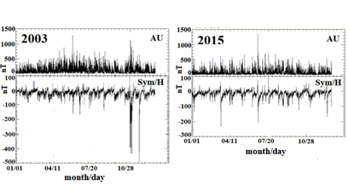 | 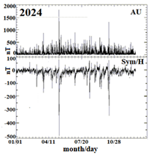
Fig. 1. The AU and Sym/H indixes for years, when extreme AU events were observed. (5-min OMNI data,).
We also found that occurrence of the extreme AU events is unevenly across years, there are more of them in years of near maximum solar activity than in years of near minimum as it is confirmed by Fig. 2.
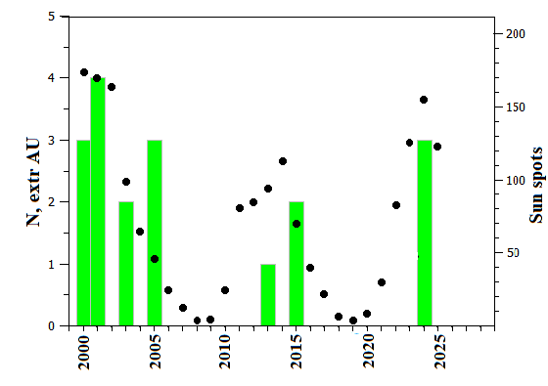
Fig. 2. Distribution of the number of extreme AU events in a year and annual average sunspot numbers in 2000–2025.
It was found that extreme AU events observed in any phase of the magnetic storms but more often in the initial and main phases of the storm. Note, of the 18 extreme events recorded in the 16 strong magnetic storms, IMF data are available for only 13. Next, let us consider several examples of extreme AU events.
3.1. Event on 24 November 2001
Fig. 3a demonstrates the initial storm phase of the magnetic storm on 24 November 2001, when the extreme AU event lasted about 2 h and associated with the strong jump of the solar wind dynamic pressure (Psw) up to ~ 35 nPa under the positive IMF By and negative IMF Bz. But the very significant Psw enhancement (up to ~70 - 80 nPa) suppressed the eastward current (AU) increasing.
The AU index has been calculated by the ABK station data, but it can be assumed that the extreme EE flowed above Siberia where no ground-based magnetic measurements (see SuperMAG map in Fig. 3b).
3. 2. Event on 1 June 2013
Fig.4 shows the time interval near the maximum (~08 UT) of the main phase of the not very strong magnetic storm (with Dstmin = -124 nT) on 1 June 2013, when the extreme AU event occurred as the short (less than 1 h) burst accompanied by fluctuations in IMF Bz under the positive IMF By without significant Psw enhancement. We also found that sometimes in the storm main phase, the AU increases represented the sequences of ~ 30 min bursts followed very strong (up to 50-60 nPa) bursts of the Psw. The AMPERE map of the ionospheric currents distribution demonstrates the narrow short (about 20 min) burst of EE currents located at high (>70° MLAT) latitudes due to the short positive IMF Bz excurse under low the solar wind pressure.
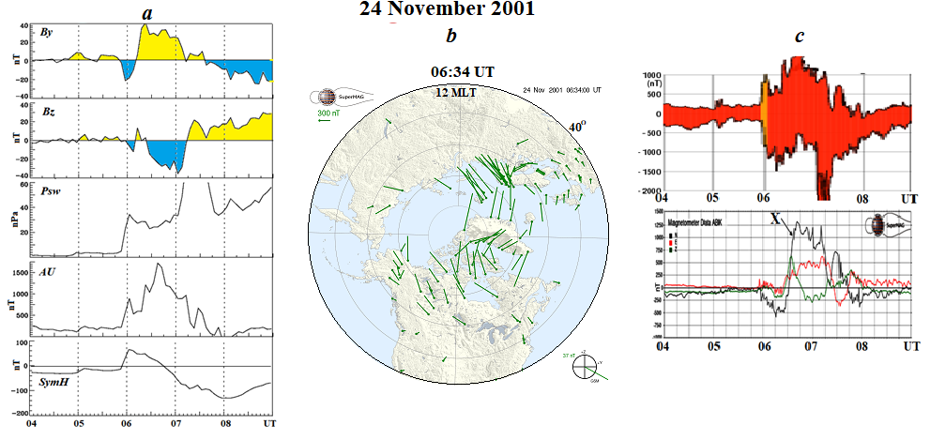
Fig. 3. (a) The most geoeffective space weather parameters (IMF Bz, IMF By and Psw) and SymH index as an indicator of magnetic storm intensity for the initial phase of the magnetic storm on 24 November 2001; (b) map in the maximum of AU index; (c) AU/AL indexes, Abisko (ABK) magnetogram for interval under consideration.

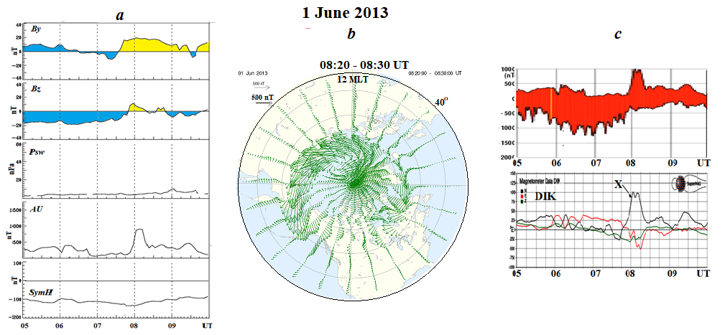
Fig. 4(a) The most geoeffective space weather parameters (IMF Bz, IMF By and Psw) and SymH index as an indicator of magnetic storm intensity for the initial phase of the magnetic storm on 24 November 2001; (b) AMPERE map of the ionospheric currents distribution near the maximum of AU index; (c) AU/AL indexes, DIXON (DIK) magnetogram for the interval under consideration.

3.3 Event on 10-11 May 2024
Fig. 5 shows the extreme AU event that occurred in the early recovery phase of the well-known very strong magnetic storm of when the ring current was very large (the SymH was ~ -300 nT). The huge increase of the AU index began with the change of the IMF By direction to the positive values under very strong negative IMF Bz (up to ~ -25 nT) and rather high Psw (up to ~ 20 nPа). In the AMPERE map (Fig 5a) one can see extremely intense eastward electrojet than located at high latitudes (>50° Mlat), its configuration may be attributed to a short positive excursion of the IMF Bz component against the backdrop of long interval (<2 hr before) of its significantly negative values (<-20 nT) under relatively low solar wind pressure (~20 nPa). It is seen the intense ionospheric currents modeled from the IMAGE measurements located close to the EE center.
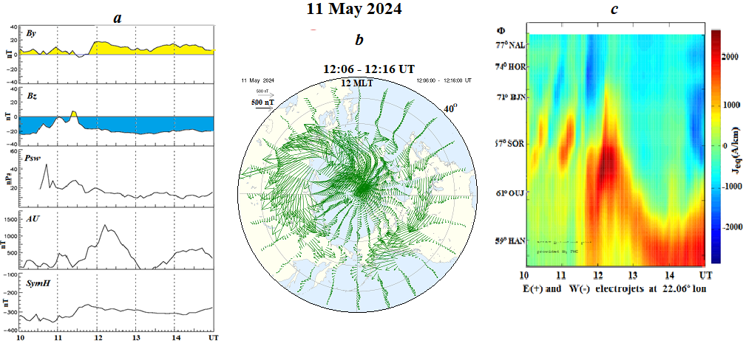
Fig.5. (a) The most geoeffective space weather parameters (IMF Bz, IMF By and Psw) and SymH index for their recovery phase of the magnetic storm on 10-11 May 2024; (b) AMPERE map of the ionospheric currents distribution near the maximum of AU index; (c) the ionospheric currents (eastward – yellow, westward – blue) from IMAGE measurements.
3. Discussion and conclusion
We studied the dependence of the eastward electrojet (EE) values in the dusk sector on the space weather conditions based on the analysis of the AU index using from the WDC Kyoto as a measure of the EE intensity.
1. The observations showed that the average upper level of AU index does not exceed 500-600 nT even in the summer periods. However, the anomalously large AU values ​​reaching or exceeding 1000 nT have been also discovered as the very large AU bursts with 1-3 h duration, which we called “extreme AU events”. Such events were recorded quite rarely and over 25 years (2000-2025) only 18 events were detected.
2. It was revealed that all 18 considered events have been observed during very strong magnetic storms with Dst< -200 nT (12 events) or strong magnetic storms with Dst< 100 nT (6 events). The “extreme AU events” could occur in any storm phase, but more often in the initial and main phases of the storm.
3. We discovered that the necessary condition for the appearance of the “extreme AU events” is positive values ​​of the AU component of the IMF By. It was previously found that the direction of intense ionospheric currents in the near-noon sector of the polar latitudes is controlled by the sign of the IMF By. Such currents were named as DPY-currents [Feldstein, 1976] or PE (polar electrojet)Feldstein et al., 2006; Friss- Christensen and Wilhjelm, 1975], i.e. the EE was observed under IMF By > 0, and the WE - during or after a long period of negative or close to zero IMF Bz values.
4. The analysis of observational data did not confirm the determining influence of the magnitude of the solar wind dynamic pressure (Psw) as well as the sign of the IMF Bz on the probability of the occurrence of the “extreme AU events”.
References
Anderson, B.J., Takahashi, K., Toth, B.A. Sensing global Birkeland currents with Iridium® engineering magnetometer data. // Geophys. Res. Lett. V. 27. P. 4045–4048. 2000. https://doi.org/10.1029/2000GL000094
Ahn, B.-H., Kroehl, H.W., Kamide, Y., Kihn, E.A. Seasonal and solar cycle variations of the auroral electrojet indices. // JASTP. V. 62. I. 14. P. 1301–1310. 2000. https://doi.org/10.1016/S1364-6826(00)00073-0
D'Onofrio, M., Partamies, N., Tanskanen, E. Eastward electrojet enhancements during substorm activity. // JASTP. V. 119. P. 129––137. 2014. https://doi.org/10.1016/j.jastp.2014.07.007
Feldstein, Y.I. Magnetic field variations in the polar region during magnetically quiet periods and interplanetary magnetic fields. //Space Sci. Rev. V. 18. P. 777–861. 1976. https://doi.org/10.1007/BF00169523
Feldstein, Y.I., Popov, V.A., Cumnock, J.A., Prigancova, A., Blomberg, L.G., Kozyra, J.U., Tsurutani, B.T., Gromova, L.I., and Levitin, A.E. Auroral electrojets and boundaries of plasma domains in the magnetosphere during magnetically disturbed intervals. // Ann. Geophys. V. 24. P. 2243–2276. 2006. https://doi.org/10.5194/angeo-24-2243-2006
Friis-Christensen, E., Wilhjelm, J. Polar cap currents for different directions of the interplanetary magnetic field in the Y-Z plane. // J. Geophys. Res. V. 80. N 10. P. 1248–1260. 1975. https://doi.org/10.1029/JA080i010p01248.
Gjerloev, J.W., Hoffman, R.A., The large-scale current system during auroral substorms. // J. Geophys. Res. Space Phys. V. 119. P. 4591–4606. 2014. https://doi.org/10.1002/2013JA019176
Tsurutani, B.T., Hajra R., Echer E., Gjerloev J.W. Extremely intense (SML ≤ –2500 nT) substorms i: Isolated events that are externally triggered? // Ann. Geophys. V. 33. N 5. P. 519–524. 2015. https://doi.org/10.5194/angeo-33-519-2015
Громова Л.И., Институт земного магнетизма, ионосферы и распространения радиоволн, РАН, gromova@izmiran.ru
Клейменова Н.Г., Институт физики Земли, РАН, kleimen@ifz.ru
Громов С.В., Институт земного магнетизма, ионосферы и распространения радиоволн, РАН, sgromov@izmiran.ru
Малышева Л.М., Институт физики Земли, РАН, mlm60@yandex.ru

Случаи экстремального усиления восточного электроджета

Л.И. Громова¹, Н.Г. Клейменова², С.В. Громов¹, Л.М. Малышева²
¹Институт земного магнетизма, ионосферы и распространения радиоволн им. Н.В. Пушкова РАН
г. Москва, г. Троицк, Россия; e-mail:gromova@izmiran.ru
²Институт физики Земли им. О.Ю. Шмидта (ИФЗ РАН), г. Москва, Россия

Абстракт. Восточный электроджет представляет собой один из важных элементов ионосферных токовых систем, связанных с различными возмущениями магнитосферы. В данной работе мы исследовали случаи экстремального усиления восточного электроджета, опираясь на его наземные магнитные проявления, характеризуемые индексом AU. Значения AU-индекса, превышающие ~900–1000 нТл, можно считать экстремальными, поскольку они почти вдвое превосходят типичные значения. Используя 5-минутные данные с портала индексов AE Мирового центра данных (WDC) в Киото, мы выявили лишь 18 событий экстремально сильного роста AU за период 2000–2025 гг. Анализ условий космической погоды, при которых наблюдались эти события, показал, что они регистрировались преимущественно во время сильных магнитных бурь (|Dstmax| > 100 нТл). Однако не каждая сильная магнитная буря сопровождалась экстремальным ростом индекса AU. Было установлено, что экстремальное повышение AU происходило только при положительных значениях компоненты By межпланетного магнитного поля (ММП) во время или после длительного периода отрицательных или близких к нулю значений компоненты Bz ММП. Экстремальный рост AU наблюдался на любых фазах магнитных бурь, но чаще всего — на начальной и главной фазах. На начальной фазе бури такие события AU были относительно редким явлением (типичная продолжительность — около 2 ч) и были связаны со скачками или весьма значительным усилением (до ~70–80 нПа) динамического давления солнечного ветра (Psw) при положительном By и отрицательном Bz ММП. На главной фазе бури эти события часто представляли собой последовательности всплесков AU длительностью ~30 мин, следовавших за очень сильными (до 50–60 нПа) всплесками давления солнечного Psw и сопровождавшихся флуктуациями Bz- и By-компонент ММП. На фазе восстановления бури очень короткие (<30 мин) всплески экстремального роста AU были связаны с резкими изменениями направления или величины компонент ММП, наблюдавшимися на фоне достаточно сильного кольцевого тока (SymH ~ −(120–150 нТл)). При этом величина Psw не являлась определяющим параметром. В работе обсуждаются детали событий, зарегистрированных во время ряда сильных магнитных бурь.

