SUPERSUBSTORMS in strong magnetic storms of the 25th solar cycle: a case study the 10-11 October 2024 storm

I.V. Despirak¹, A.A. Lubchich¹, N.G. Kleimenova²

¹Polar Geophysical Institute, Apatity, Russia; e-mail: despirak@gmail.com
²Schmidt Institute of the Physics of the Earth RAS, Moscow, Russia

Abstract. The current 25-th solar cycle began in December 2019 and peaked in 2024-2025, is characterized by very strong magnetic storms, during which geomagnetic disturbances were observed at unusually low geomagnetic latitudes. Strong magnetic storms are often accompanied by intense and very intense substorms, so-called supersubstorms (SSS), which were identified as a separate substorm type relatively recently. Supersubstorms were defined as substorms with very high values of the SML index of geomagnetic activity (< -2500 nT). Although this value was chosen arbitrarily, it is still used as an estimate, since it is important to have a quantitative description of the phenomenon. Until recently it was found that SSS are a relatively rare phenomenon observed mainly during intense, major storms and superstorms, when high values of the southward IMF and solar wind dynamic pressure are recorded. Besides supersubstorms, unlike regular substorms, have been shown to have a different auroral evolution and a specific character of magnetic disturbances, including convective magnetic bays development. It was also found that the supersubstorms are mainly observed during magnetic storms caused by CME. The features of supersubstorms during some strong storms during 25th solar cycle are examined, and their various possible solar wind and IMF drivers are discussed.

Introduction
The current solar cycle 25, which began in December 2019 and is reaching its peak in 2024–2025, is characterized by very strong magnetic storms, during which disturbances were observed at unusually low geomagnetic latitudes. For example, during the most intense magnetic storm of Solar Cycle 25—the superstorm of May 10–12, 2024 (Dst ~ −412 nT, SYM/H ~ −518 nT)—intense magnetic disturbances were recorded at latitudes of ~35–40° MLAT [Zou et al., 2025; Kleimenova et al., 2025; Despirak et al., 2025], while auroras were observed in Cuba and Mexico [Gonzalez-Esparza et al., 2024; Foster et al., 2024]. At the same time, strong magnetic storms are often accompanied by intense and very intense substorms—so-called supersubstorms (SSS)—which were identified as a distinct type of substorm relatively recently. Substorms with very high values of the SML-index (< −2500 nT) have been termed "super-substorms" [Tsurutani et al., 2015]. Early studies of supersubstorms focused on the conditions of their occurrence and their relationship with the interplanetary electric and magnetic fields, different solar wind streams and structures, magnetic storms, and the generation of geomagnetically induced currents (GIC) in technological networks [Haira et al., 2016; Despirak et al., 2019; Tsurutani and Haira, 2023; Despirak et al., 2023, 2024].
The development characteristics of auroral disturbances (auroras and electrojets) during SSSs were investigated. The analysis of the planetary distribution of the ionospheric electrojets and field-aligned currents (FACs) during SSS shown that the westward electrojet developed in the global scale (from before midnight, through the night and morning, and into the day sector). It was also found that in the evening sector the strong magnetic vortex of the upward currents exists corresponded to the very strong eastward current observed from afternoon to evening sector [Despirak et al., 2020, 2022]. However, note that these studies focused on the analysis of individual events. All our studied SSS events are shown at the Figure 1. It is seen that the study was connected to SSS events in the Solar Cycle 24. However, the study of SSS during the intense magnetic storms in the beginning of the new Solar Cycle 25 (May, October 2024, etc.) has revealed that SSSs can evolve according to a different scenario and exhibit features that were not observed in earlier studies of cycle 24 supersubstorms.
The aim of this study is to analyze various scenarios of ionospheric current development during supersubstorms, using the magnetic storm of 10-11 October 2024 as a case study. It should be noted that the October event was selected due to its relative simplicity for analysis, as it was triggered by a single coronal mass ejection (CME) with clearly defined boundaries between the sheath region and the magnetic cloud (MC). The analysis was carried by the data collected from the ground-based geomagnetic networks SuperMAG (http://supermag.jhuapl.edu/) and IMAGE (http://space.fmi.fi/image/) as well as the magnetic registrations by the AMPERE project satellites (http://ampere.jhuapl.edu/products). Solar wind and interplanetary magnetic field (IMF) conditions were determined using the CDAWeb OMNI database (http://cdaweb.gsfc.nasa.gov/).
The origins of the October 10-11, 2024 storm are the disk-center X1.8 flare at ~ 02:00 UT on October 9, 2024 and the full-halo coronal mass ejection (CME) with an initial speed of ~ 1000 km/s [Kataoka et al., 2025]. The interplanetary shock was observed at ~ 15:20 UT on October 10, 2024. There was a total of three supersubstorms during this magnetic storm: at ~15:55 UT and ~17:06 UT on 10 October, and at ~08:15 UT on 11 October, 2024 (Figure 2).
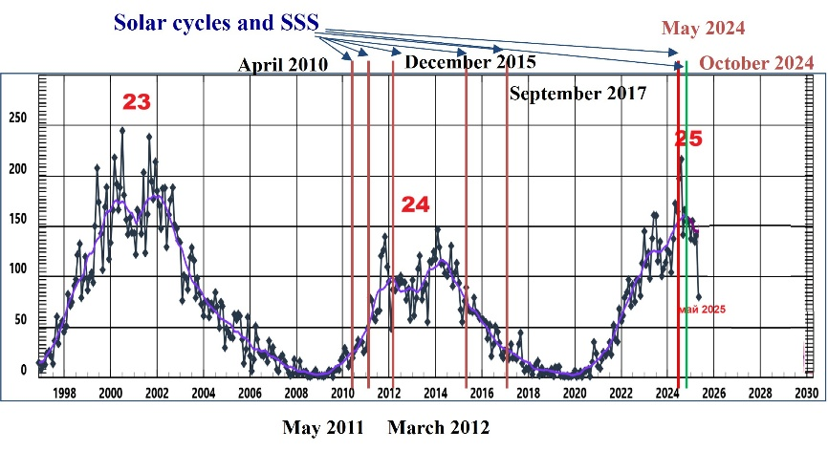

Figure 1. Some supersubstorms and 23, 24 and 25 solar cycles. Events of supersubstorms studied in previous works are marked by red vertical lines; supersubstorms studied in this work are marked by green lines.

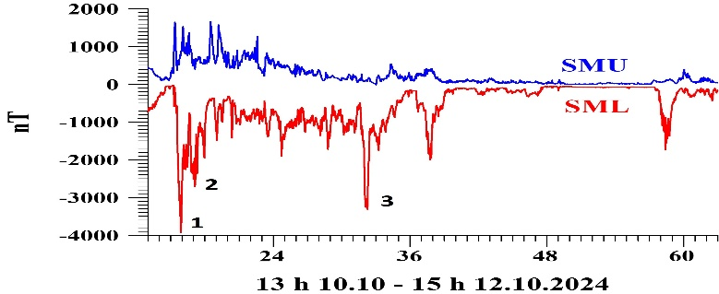

Figure 2. SML- and SMU- indexes from 13 UT on 10 October to 15 UT on 12 October 2024. Three supersubstorm events are marked with the corresponding numbers.

Results
1. SSS-1 (Type-1, non-typical development)
The development of magnetic disturbances, planetary distribution of the ionospheric electrojets and FACs during SSS-1 as well as solar wind conditions are shown at the Figure 3. It is seen that the large magnetic disturbance (SSS-1, SML~4000 nT) occurred at ~15:55 UT immediately after the interplanetary shock registered at ~ 15:20 UT on October 10, 2024 (Figure 3a). Note that at the leading edge of the Sheath characterized by very high solar wind dynamic pressure (Psw ~40 nPa) and positive values of the IMF Bz and By components; but then at 15:30 UT, the sign of the IMF Bz and By changed to negative, and a huge (~ 4000 nT) supersubstorm began. According to the SuperMAG map (Figure 3b), strong magnetic disturbances were registered only in the morning and daytime MLT sectors over Alaska, whereas strong disturbances were absent in the night and evening sectors. It is also confirmed by the AMPERE magnetic vector map, which shows the development of a large-scale ionospheric vortex rotating clockwise in the morning sector (Figure 3d). It is seen that an increasing of two-vortex DP2 current system was detected, confirming a significant increase in ionospheric convection. But the DP1 current system in the night sector, typical of a substorm, was absent. Variations of X-components of the magnetic field at station Alaska demonstrated that SSS-1 began near the polar boundary of the auroral oval and during the expansion phase the disturbances propagated from high- to lower latitudes (Figure 3c), which is atypical for a substorm. Thus, SSS-1 was atypical, because it began in the daytime rather than nighttime sector, it was near the polar boundary of the auroral oval, during the expansion phase the ionospheric current rapidly propagated to lower rather than higher latitudes, the peak amplitude of the substorm reached about 4000 nT in a very local region in the absence of the extended westward electrojet in night sector.
We supposed that the source of SSS-1 atypical development may be the feature in the solar wind before SSS-1: very high solar wind dynamic pressure and the short period of negative Bz; besides the Bz component was predominantly positive before to the SSS. The high dynamic pressure drove an intensification of the ionospheric convection and, consequently, of the DP12 current system.

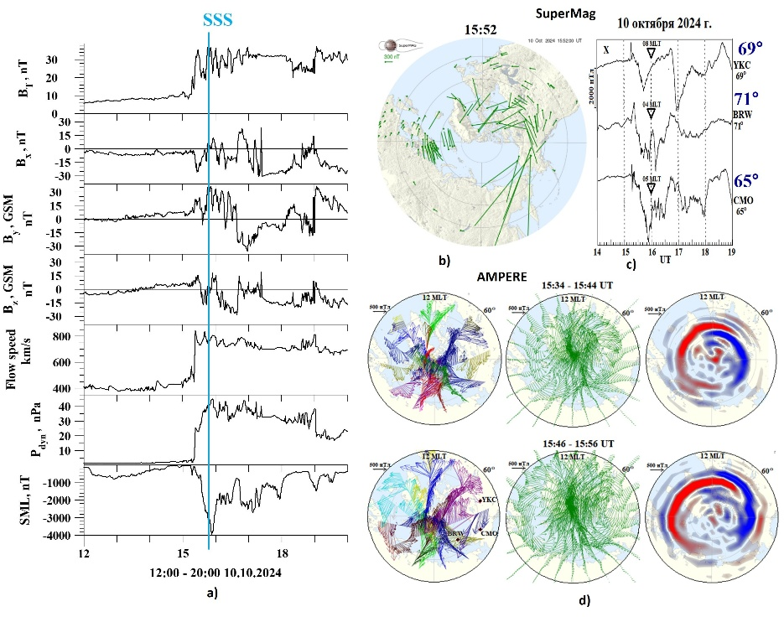

Figure 3. SSS-1: solar wind and IMF conditions on 12-20 UT on 10 October 2024, the moment of SSS-1 is marked by blue vertical line (a); maps of magnetic vectors rotated to 90° clockwise from SuperMag network (b); Variations of the X-components of Alaska stations (YKC, BRW, CMO) (c); AMPERE map of the magnetic disturbances, spherical harmonic analysis of magnetic disturbances and equivalent field-aligned currents (FACs) for the moments corresponding the moments of the onset and maximum of SSS-1: 15:34-15:44 UT and 15:46 -15:56 UT on 10 October 2024 (d).

2. SSS-2 (Type-2, non-typical development)
The development of magnetic disturbances, ionospheric currents and solar wind conditions for SSS-2 are shown at the Figure 4. The Format of Figure 4 is the same as Figure 3. As seen from Figure 4a unlike SSS-1 the long period of large negative Bz IMF (~ - 40 nT) was observed before to SSS-2 on the background of the high solar wind dynamic pressure, whereas the northward turnings of the IMF Bz component could have triggered the SSS-2 registered at ~17:05 UT on 10 October 2024 (SML ~ - 2800 nT). Therefore, the distribution of the magnetic disturbances is different than for SSS-1. According to the SuperMAG map, strong magnetic disturbances were registered also in the morning MLT sectors over Alaska (Figure 4b), but variations of X-components of some Alaska station demonstrated that during expansion phase of the SSS-2 the negative bays propagated from low to high latitudes (Figure 4c), i.e. the expansion of the disturbances to the pole was observed. However, according to the AMPERE maps, showing the local clockwise rotating ionospheric vortex in the morning sector, the strongest disturbances being a supersubstorm; but additionally, the extended westward electrojet developed at lower latitudes, from the morning (~10 MLT) to the pre-midnight sector (~22 MLT) (Figure 4d). Thus, maximum of SSS-2 developed in Alaska sector, but the strong westward electrojet propagated to the West and reach the midnight sector with strong disturbances at the subauroral and middle latitudes.

3. SSS-3 (Type-3, typical development)
Unlike SSS-1 and SSS-2 occurred during the Sheath region, the SSS-3 was observed in the magnetic cloud (MC) during a long period of strong (~30 nT) Bz<0. In additional, before SSS-3, the local structure in the solar wind was registered (Figure 5a) caused by slightly increased pressure, velocity and strong magnetic field disturbances. A prolonged period of the negative IMF Bz combined with the local structure can be a possible trigger of the SSS-3. Unlike SSS-1 and SSS-2, strong magnetic disturbances were registered in the night MLT sectors where Alaska stations were located (Figure 5b). Variations of X-components of some Alaska stations shown strong negative bays (~-3000 nT) propagated from low to high latitudes (Figure 5c). It is also confirmed by the AMPERE maps, which shows the development of the extended westward electrojet in the global scale (from before midnight, through the night and morning, and into the day sector). The SSS-3 demonstrated a typical SSS development characterized by the strongest disturbances in the nighttime sector, with an extended westward electrojet from the night to the morning side.

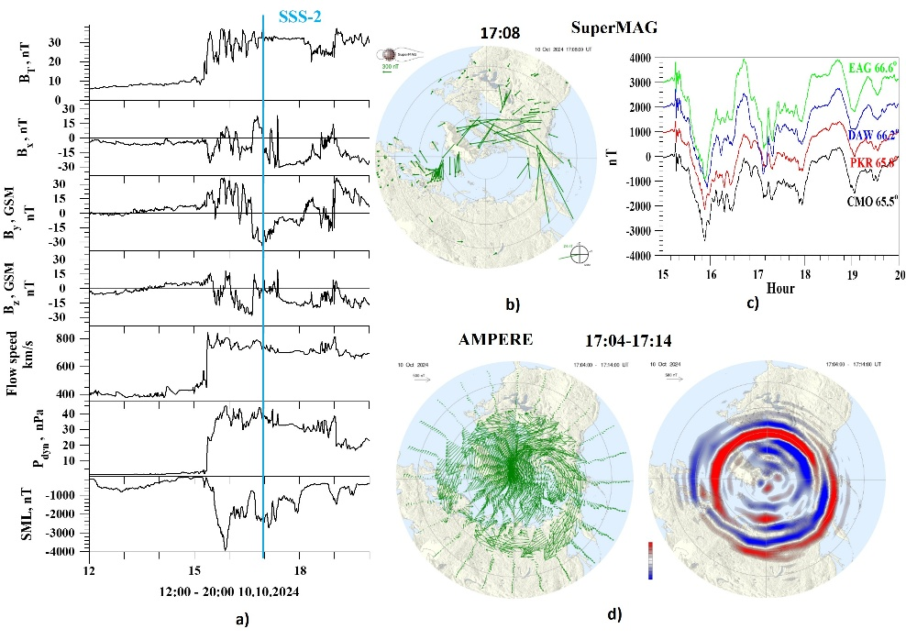

Figure 4. SSS-2: solar wind and IMF conditions on 12 - 20 UT on 10 October 2024, the moment of SSS-2 is marked by blue vertical line (a); map of magnetic disturbances from SuperMag network (b), X-components of some Alaska stations (DAW, EAG, CMO, PKR) (c); AMPERE map of the spherical harmonic analysis of magnetic disturbances and FACs for the SSS-2 maximum: 17:04-17:14 UT on 10 October 2024 (d).

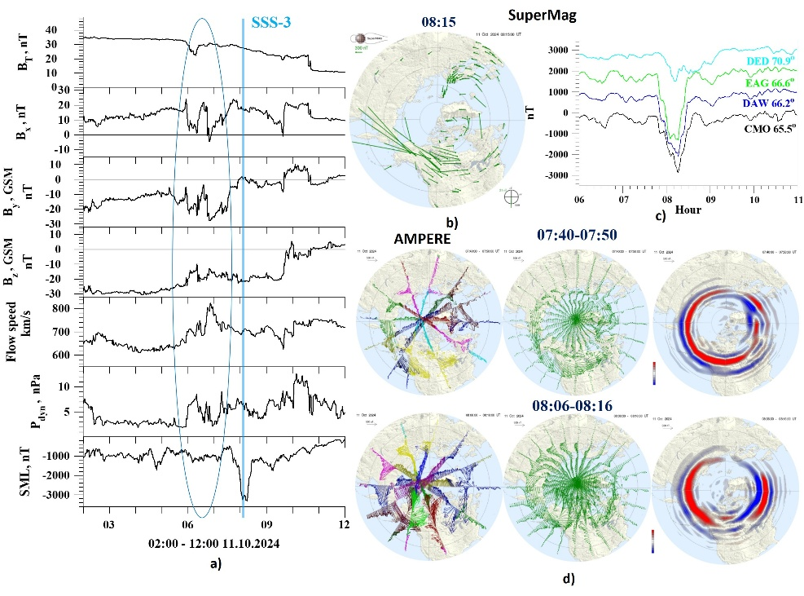
Figure 5. SSS-3: solar wind and IMF conditions on 02 - 12 UT on 11 October 2024, the moment of SSS-3 is marked by blue vertical line and the local structure is marked by blue oval (a); map of magnetic disturbances from SuperMag network (b), X-components of some Alaska stations (DED, DAW, EAG, CMO) (c); AMPERE map of the magnetic disturbances, spherical harmonic analysis of magnetic disturbances and FACs for the SSS-2 onset and maximum (d).

Conclusions
New features of ionospheric current development during SSS have been identified: Type-1 (SSS-1): The development of large magnetic disturbances in the daytime and morning sectors due to the formation of a large-scale clockwise-rotating ionospheric vortex. The SCW in the night sector, typical of a substorm, was absent. Type-2 (SSS-2): In addition to the vortex in daytime and morning sectors, an enhanced westward electrojet appears, flowing at low latitudes on the morning side. Type-3 (SSS-3): A typical SSS development is characterized by the strongest disturbances in the nighttime sector, with an extended westward electrojet from the morning to the daytime side.
We suggested that the different development patterns of the three supersubstorms are associated with changes in solar wind parameters and with the features of the coronal mass ejections (CMEs) caused the magnetic storm.

Acknowlegments
The authors gratefully acknowledge the OMNI (https://cdaweb.gsfc.nasa.gov/), the SuperMAG (http://supermag.jhuapl.edu/), AMPERE (http://ampere.jhuapl.edu) teams for providing access to their data and tools used in this study.

References
Despirak I.V., Lyubchich A.A., Kleimenova N.G. (2019). Supersubstorms and conditions in the solar wind. Geomagnetism and Aeronomy, V. 59, No. 2, P. 170–176. https://doi.org/10.1134/S0016793219020075
Despirak I.V., Kleimenova N.G., Gromova L.I., Gromov S.V., Malysheva L.M. (2020). Supersubstorms during storms of September 7–8, 2017. Geomagnetism and Aeronomy, V. 60, No. 3, P. 292–300. https://doi.org/10.1134/S0016793220030044
Despirak I.V., Kleimenova N.G., Lyubchich A.A., Setsko P.V., Gromova L.I., Werner R. (2022). Global Development of the Supersubstorm of May 28, 2011. Geomagnetism and Aeronomy, V. 62, No. 3, P. 199–208. DOI: 10.1134/S0016793222030069
Despirak I.V., Setsko P.V., Sakharov Ya.A., Lubchich A.A., Selivanov V.N. (2023). Geomagnetically induced currents during supersubstorms on September 7-8, 2017. Bulletin of the Russian Academy of Sciences: Physics, V. 87, P. 999–1006. https://doi.org/10.3103/S1062873823702283
Despirak I., Setsko P., Lubchich A., Hajra R., Sakharov Ya., Lakhina G., Selivanov V., Tsurutani B.T. (2024). Geomagnetically induced currents (GICs) during strong geomagnetic activity (storms, substorms, and magnetic pulsations) on 23–24 April 2023. Journal of Atmospheric and Solar-Terrestrial Physics, V. 261, Art. 106293. https://doi.org/10.1016/j.jastp.2024.106293
Despirak I., Setsko P., Lubchich A., Sakharov Ya., Selivanov V. (2025). Geomagnetically Induced Currents (GICs) during strong geomagnetic storm on 10–12 May 2024. Advances in Space Research, V. 76, Is. 12, P. 7546–7563. https://doi.org/10.1016/j.asr.2025.06.081
Gonzalez‐Esparza J.A., Sanchez‐Garcia E., Sergeeva M., Corona‐Romero P., Gonzalez‐Mendez L.X., Valdes‐Galicia J.F., et al. (2024). The mother’s day geomagnetic storm on 10 May 2024: Aurora observations and low latitude space weather effects in Mexico. Space Weather, V. 22, Is. 11, Art. e2024SW004111. https://doi.org/10.1029/2024SW004111
Foster J.C., Erickson P.J., Nishimura Y., Zhang S.R., Bush D.C., Coster A.J., Meade P.E., Franco-Diaz E. (2024). Imaging the May 2024 extreme aurora with ionospheric total electron content. Geophysical Research Letters, V. 51, Is. 20, Art. e2024GL111981. https://doi.org/10.1029/2024GL111981
Hajra R., Tsurutani B.T., Echer E., Gonzalez W.D., Gjerloev J.W. (2016). Supersubstorms (SML < -2500 nT): Magnetic storm and solar cycle dependences. J. Geophys. Res. Space Physics, V. 121, Is. 8, P. 7805–7816. https://doi.org/10.1002/2015JA021835
Kataoka R., Nakano S., Uchino S., Reddy S.A. (2025). Extended red aurora associated with super substorm igniting the October 10, 2024 magnetic storm as revealed by citizen science. Earth, Planets and Space, V. 77, Art. 64. https://doi.org/10.1186/s40623-025-02178-w
Kleimenova N.G., Gromova L.I., Gromov S.V., Malysheva L.M. (2025). Planetary feature of ionospheric current activity during 10-11 October 2024 extremely strong magnetic storm. Journal of Atmospheric and Solar-Terrestrial Physics, V. 277, Art. 106631. https://doi.org/10.1016/j.jastp.2025.106631
Tsurutani B.T., Hajra R., Echer E., Gjerloev J.W. (2015). Extremely intense (SML ≤ –2500 nT) substorms: Isolated events that are externally triggered? Ann. Geophys., V. 33, P. 519–524. https://doi.org/10.5194/angeo-33-519-2015
Tsurutani B.T., Hajra R. (2023). Energetics of Shock-triggered Supersubstorms (SML < −2500 nT). The Astrophysical Journal, V. 946, No. 1. https://doi.org/10.3847/1538-4357/acb143
Zou Y., Shin O., Gjerloev J.W., Anderson B.J, Waters C.L., Wang C., Liang J., Lyons L.L., Bhatt A. (2025). Are supersubstorms substorms? Extreme nightside auroral electrojet activities during the May 2024 geomagnetic storm J. Geophys. Res. Space Physics, V. 130. Art. e2024JA033303. https://doi.org/10. 1029/2024JA033303

СУПЕРСУББУРИ ВО ВРЕМЯ СИЛЬНЫХ МАГНИТНЫХ БУРЬ 25 ЦИКЛА СОЛНЕЧНОЙ АКТИВНОСТИ: ОТДЕЛЬНЫЕ СЛУЧАИ

И.В. Дэспирак¹, А.А. Любчич¹, Н.Г. Клейменова²

¹Полярный геофизический институт, Апатиты, Россия, despirak@gmail.com;
² Институт физики Земли, РАН, Москва, Россия

Абстракт
Текущий 25-й цикл солнечной активности, начавшийся в декабре 2019 года и достигший пика в 2024–2025 годах, характеризуется очень сильными магнитными бурями, в ходе которых геомагнитные возмущения наблюдались на необычно низких геомагнитных широтах. Сильные магнитные бури часто сопровождаются интенсивными и очень интенсивными суббурями — так называемыми суперсуббурями (SSS), которые были выделены в отдельный тип суббурь относительно недавно. Суперсуббури определяются как суббури с очень большими значениями SML-индекса геомагнитной активности (< -2500 нТл). Хотя это пороговое значение было выбрано произвольно, оно по-прежнему используется для оценки, поскольку важно иметь количественное описание данного явления. До недавнего времени считалось, что суперсуббури — это относительно редкое явление, наблюдаемое преимущественно во время интенсивных и сильных бурь, а также супербурь, когда регистрируются высокие значения южной компоненты межпланетного магнитного поля (ММП) и динамического давления солнечного ветра. Кроме того, было показано, что суперсуббури, в отличие от обычных суббурь, характеризуются иной динамикой развития полярных сияний и другим характером магнитных возмущений, включая развитие конвективных магнитных бухт. Также было установлено, что суперсуббури наблюдаются главным образом во время магнитных бурь, вызванных выбросами корональной массы (CME). В работе рассматриваются особенности суперсуббурь, зафиксированных во время некоторых сильных бурь 25-го солнечного цикла, а также обсуждаются возможные факторы, связанные с параметрами солнечного ветра и ММП, которые могут их генерировать.

E-mails:
И.В. Дэспирак despirak@gmail.com
А.А. Любчич lubchich@pgia.ru
Н.Г. Клейменова kleimen@ifz.ru

