Study of the geoelectric structure of the Earth’s crust by the phase-gradient sounding method
Petrishchev M.S., Kopytenko Yu.A., Ismagilov V.S., Tkachev A.L., Sergushin P.A.
Pushkov institute of terrestrial magnetism, ionosphere and radio wave propagation of the Russian Academy of Sciences St.-Petersburg Branch (SPbF IZMIRAN), St.Petersburg, Russia, e-mail: ms_petr@mail.ru

Abstract. The phase-gradient sounding (PGS) method was employed to map crustal geoelectric structures and identify the potential reservoirs for an enhanced geothermal system (EGS) in the Fennoscandian Shield near Helsinki, Finland. To overcome challenges from intense anthropogenic noise, measurements were conducted using only magnetic field components. The obtained geoelectric model revealed a promising sub-horizontal low-resistivity layer at 4.8-6.3 km depth interpreted as a rheological weakened zone. This interpretation was verified by its correlation with regional fault systems and seismicity. The practical value of the study was confirmed when identified layer was successfully targeted for drilling and hydraulic stimulation of the OTN-2 well demonstrating the efficacy of the PGS method for EGS site characterization in challenging environments.
- Introduction
The objective of our independent investigations was to identify and characterize conductive layers within the Earth’s crust. Such layers can be interpreted as rheological weakened zones, making them promising targets for the development of Enhanced Geothermal Systems (EGS) for heat and power generation. These geoelectric studies were carried out in January 2019 near Helsinki, Finland, initiated by SPbF IZMIRAN with the support of S. Puuppo’s team and were separate from the ongoing St1 Deep Heat pilot project. The phase-gradient sounding method (Kopytenko et al., 2015) was employed for this purpose.
The St1 Deep Heat project, which aims to build Finland’s first industrial-scale geothermal plant in Otaniemi, is an example of an EGS, designed to extract energy from hot dry rock through hydraulic stimulation. As of July 2018, prior to our measurements, it was drilled OTN-3 injection well (6.4 km deep) and the OTN-2 observation well (2 km deep) located close to it and used for seismic monitoring. Site selection was underway for a production well which was to be located in close proximity to the injection well. Providing recommendations for the optimal placement of this production well was a key goal of our study.

- Methodology and data
Basic principles of the phase-gradient sounding (PGS) method are following. An electromagnetic wave passing through the atmosphere and incident on the Earth’s surface propagates at the speed of light, and its phase delay between the observation points located on the Earth’s surface is close to zero. However, at each observation point on the Earth’s surface, we observe the sum of incident and reflected electromagnetic waves. The phase velocities of electromagnetic wave propagation, as well as the gradients of the vertical component of the magnetic field variations along the Earth’s surface, depend on the peculiarities of the geoelectrical structure of the Earth’s crust; hence, the experimentally observed phase delays (Δt₁… Δt₃) are nonzero (Kopytenko et al., 2015). We can determine the apparent resistivity of the medium, if the phase velocity of electromagnetic wave propagation along the Earth’s surface is known. Then we can use the methods of interpretation of magnetotelluric soundings (MTS) for building the geoelectrical model of the media.
Only the magnetic components of the electromagnetic field were used in this study. This approach was necessitated by the extensive electrification of the region, where high levels of electromagnetic noise complicate the recording of natural magnetotelluric currents and adequate interpretation of MTS data. The PGS method involves synchronous observations (referenced via GPS/GLONASS) using highly sensitive magnetic stations positioned at the vertices of triangles. For the center of each triangle (virtual PGS point), vectors of the gradient and phase velocity of propagation of geomagnetic disturbances along the Earth’s surface can be constructed, enabling calculation of the apparent resistivity of the Earth’s crust in different frequency bands. The GI-MTS-1 equipment (Sergushin and Petrishchev, 2022) with a frequency range of 0-15 Hz was used for these measurements.
The gradients of the geomagnetic field components are very small at a short spacing (4–15 km) between base magnetic stations. When three-component stations are installed in the field, ideal alignment of the spaced magnetic sensors can hardly be accomplished. In this respect, the PGS method involves full horizontal and vertical components and variations in the modulus of the full magnetic field vector for constructing the vectors of gradients and phase velocities, because these parameters do not depend on the orientation of magnetic sensors.
A 20-km profile centered on the OTN-3 injection well was established (Fig. 1) with a measurement spacing of 2 km. Fieldwork was completed within four days, during which 22 physical stations were installed to obtain 11 virtual PGS points. The measurement protocol included both daytime (3-hour sessions) and nighttime recording. All stations were deployed in parks or on the ice-covered surface of the Gulf of Finland.
- Results
After processing, three of the eleven PGS points were classified as poor quality due to the high level of industrial electromagnetic noise. These include the two northeastern most points (s10 and s11) of the profile, located in close proximity to a railroad station, as well as point s04. Notably, measurements at these stations were conducted during the daytime when the anthropogenic noise is typically highest. It should be noted that the PGS curves built from variations in the full horizontal magnetic component for this area coincide with the results calculated from the vertical component. Therefore, the subsequent discussion will focus solely on the results obtained from the vertical magnetic component.

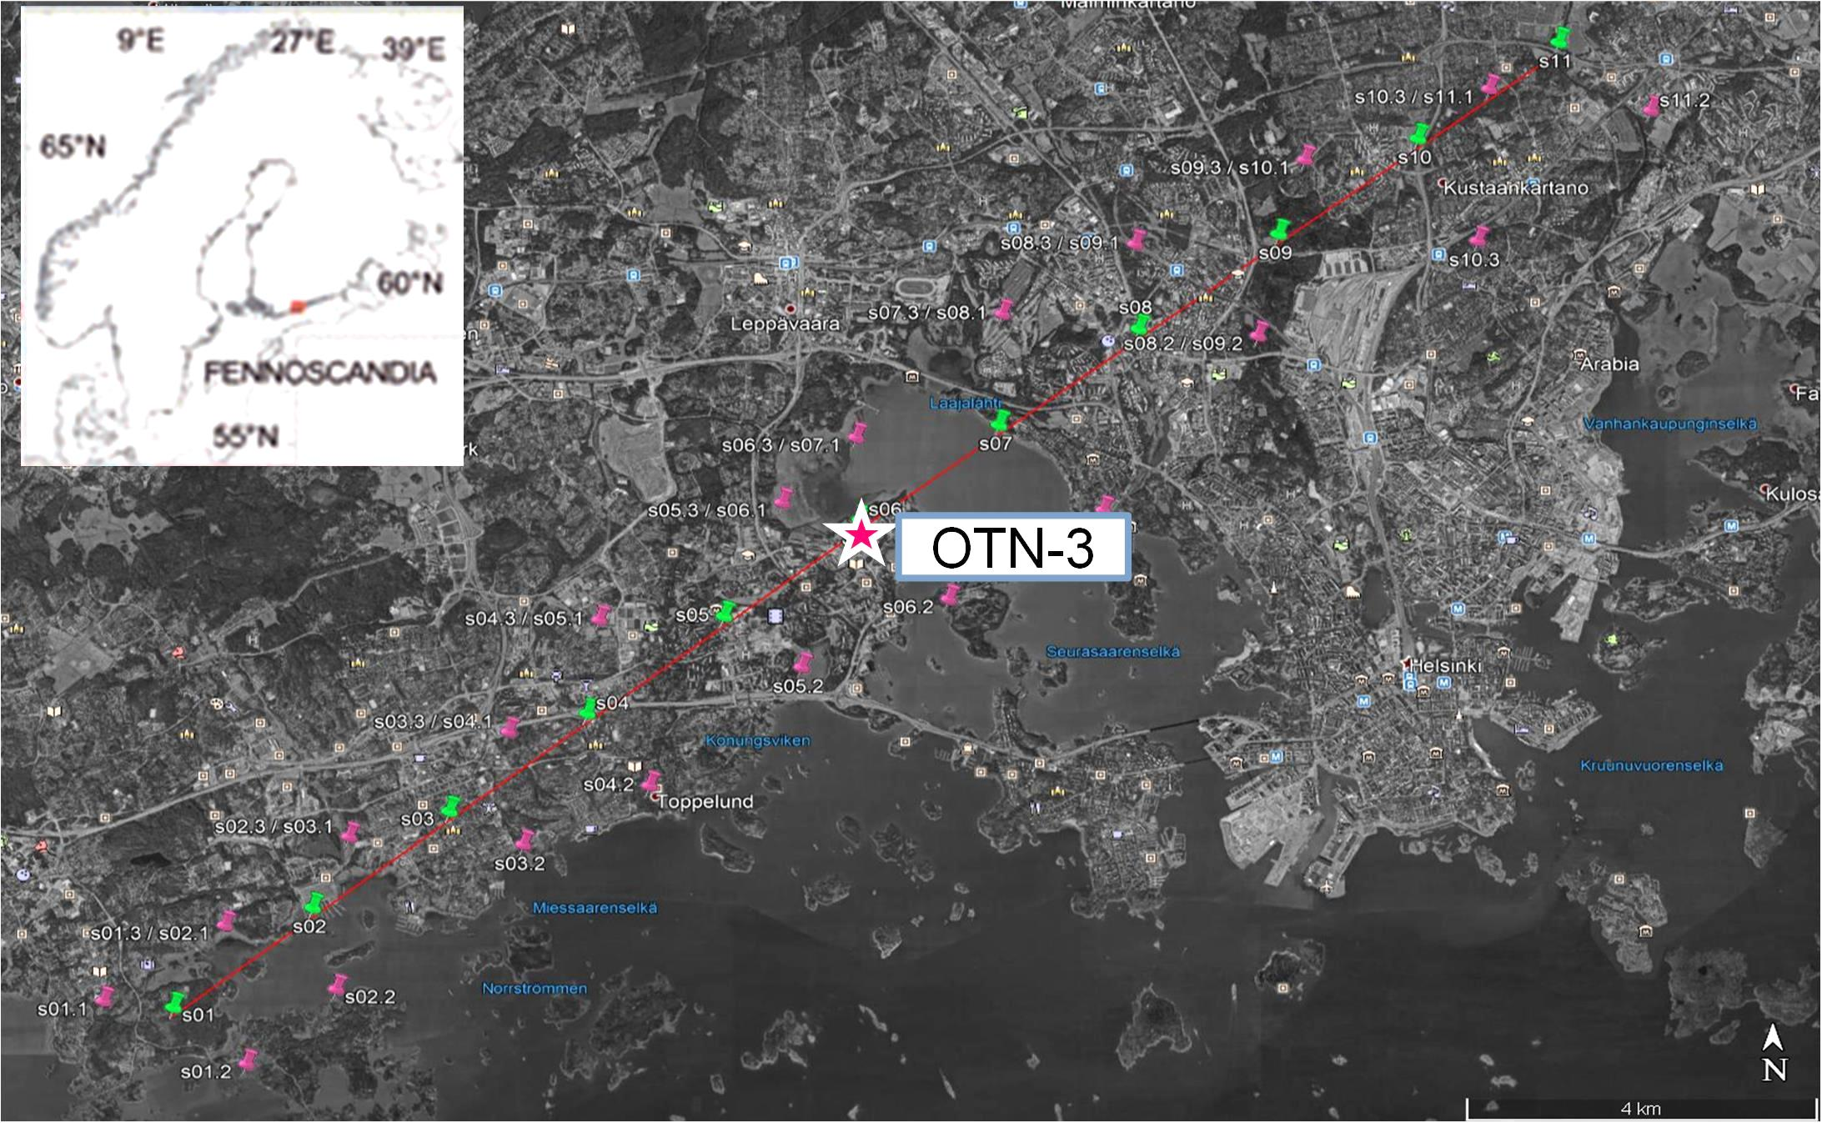
Fig. 1. Scheme of the profile. Physical stations are shown in pink, virtual PGS points – in green. Star denotes the location of the OTN-3 well.
Due to a shift in the apparent resistivity (Fig. 2) a correction was applied using the regional mantle conductivity as a reference. The discrepancy between the regional responses and the PGS results was first addressed by incorporating data from the Nurmijarvi observatory (Korja, 1998) located approximately 20 km from the profile, as a part of the Baltic Electromagnetic Array Research. This combined correction is shown in blue in Fig. 2a. All PGS results were subsequently corrected against this adjusted curve, yielding a solution with good internal consistency across the study area. The lack of impedance phase data precludes the direct application of inversion to the experimental data. Therefore, a technique of controlled transformation of unsmoothed data was employed, following the methodology outlined by Vagin (2012). This allowed for the construction of 1D models for each PGS point, presented in Fig. 2b.
The experimental results are valid for depths ranging from approximately 3.5 to 15 km. The geoelectric section is characterized by a gradient decrease in resistivity, from 1000-2000 Ohm·m at 3.5 km depth to about 40 Ohm·m at 4.5 depth. The structure of the deeper layer exhibits some variations and requires a 2D analysis. A quasi-2D geoelectric model for the profile was constructed by gridding the 1D models using a minimum curvature method (Fig. 3).
The geoelectric section reveals key features. On the right flank of the profile near stations s07-s09 a sub-vertical conductive channel (10-20 Ohm·m) is identified, potentially bounded by fault zones. This structure can be traced from a depth of 14 km up to approximately 5 km and is interpreted as a pathway for upward fluid migration, which could induce metamorphic changes in the rock. Another significant feature is a sub-horizontal low-resistivity layer (10-30 Ohm·m) at a depth of 4.8-6.3 km, extending from the mid-profile (station s05) to the right flank (station s09), in the vicinity of the OTN-3 well.
A comparison with known geological features shows a strong correlation between two known faults and the conductive boundaries identified in our section (Fig. 3). Furthermore, analysis of seismological bulletins revealed a magnitude M1.6 earthquake that occurred on 3 February 2013 near stations s08 and s09 at a depth of 5 km (IRIS data service; coordinates 60.21⁰N, 24.91⁰E). The catalogue of the Finnish permanent seismic network also lists two earthquakes recorded in 2017 at a depth of 5 km near station s06, located near OTN-3 well site prior to the commencement of hydraulic stimulation in 2018.

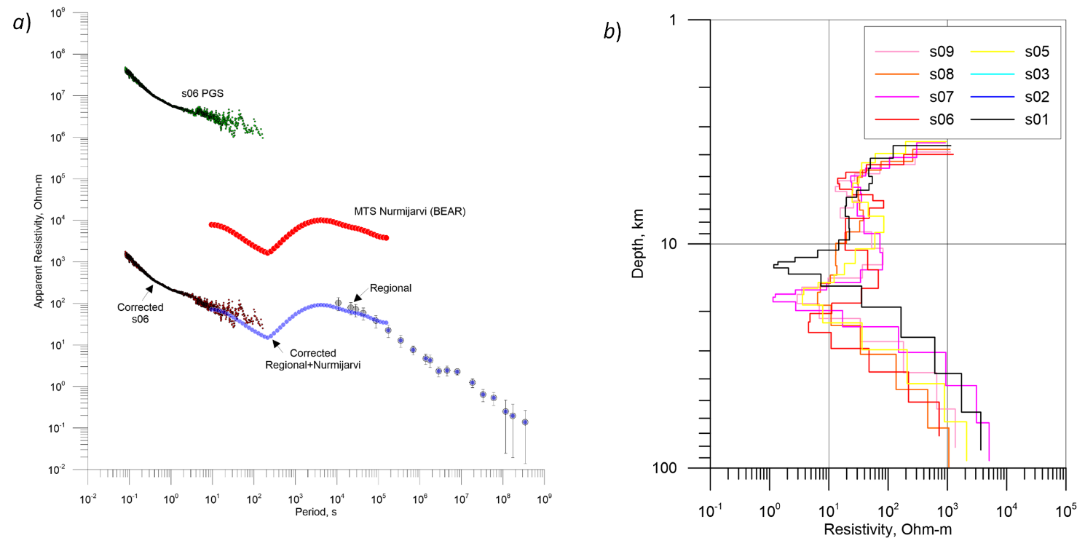
Fig. 2. Correction of the shift for the experimental data on the example of s06 point (a) and 1D models for PGS points (b).
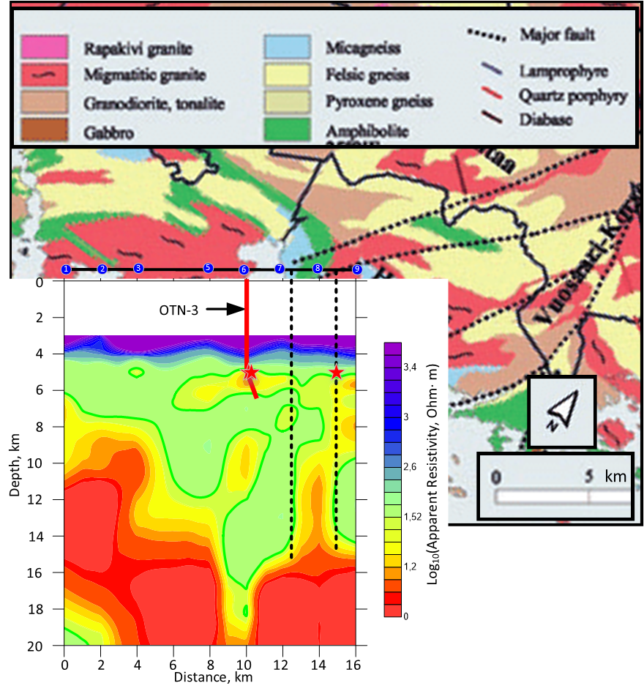
Fig. 3. Correlation of the geoelectric section with features of the lithological map (Pajunen et al., 2008) and earthquake hypocenters (red stars). The red line indicates the trajectory of the OTN-3 well.

Based on the 2019 geoelectric interpretation, the conductive layer at 4800-6300 m depth was identified as a potential reservoir for hydraulic stimulation. Recommendations were made to drill the production well northeast of OTN-3, towards the nearest fault zone identified in the section. By spring 2020 these findings were validated through drilling the OTN-2 observation well was drilled to a depth of approximately 5700 m with a section parallel to the OTN-3 well starting from 4900 m depth; the wellbores are spaced about 400 m apart horizontally (Kwiatek et al., 2022). The OTN-2 well was drilled in a north-eastern direction and a successful hydraulic stimulation was conducted in 2020 within the depth interval of 4856-5765 m to establish connectivity between two wells.
This study demonstrates the effectiveness of the PGS method for investigating crustal structures, particularly in the context of EGS. The method is also highly suitable for geological exploration in challenging environments, including mountainous regions, deserts, seismically active zones, offshore areas, and ice fields in the Arctic and Antarctic.

References
- Kopytenko Yu.A., Ismaguilov V.S., Petrishchev M.S. (2015). Investigation of the geoelectrical structure of the Earth’s crust by phase-gradient sounding. Doklady Akademii Nauk, 462(3), 352–355. DOI: 10.1134/S1028334X15050232.
- Korja T. (1998). Baltic Electromagnetic Array Research, EUROPROBE News, pp. 4-5, 12, August, 1998.
- Kwiatek G., Martínez-Garzón P., Davidsen J., Malin P., Karjalainen A., Bohnhoff M., Dresen G. Limited earthquake interaction during a geothermal hydraulic stimulation in Helsinki, Finland // Journal of Geophysical Research: Solid Earth. 2022. V. 127. e2022JB024354. DOI: 10.1029/2022JB024354.
- Pajunen M, Airo M.-L., Tuija E., Niemelä R., Juha S., Vaarma M., Wasenius P., Wennerström M., Elminen M.-L., Salmelainen R., Vaarma J. (2008). Construction suitability of bedrock in the Helsinki area based on the tectonic structure of the Svecofennian crust of southern Finland. Geological Survey of Finland, Special Paper 47, 309–326.
- Sergushin P.A., Petrishchev M.S., 2022. The GI-MTS-1 Geophysical Station and Its Application for Localizing Sources of Electromagnetic Disturbances. Proceedings of the Scientific and Practical Seminar "Study of the Earth's Magnetic Field as a Factor in Advancing Russia's National Security." St. Petersburg: ETU "LETI," St. Petersburg Branch of IZMIRAN, 2022. – P. 68–70 (in Russian).
- Vagin S.A. (2012). Controlled transformation of unsmoothed magnetotelluric data. Questions of geophysics (SPb state University). 45, 62 – 66 (in Russian).

Петрищев М.С., Санкт-Петербургский филиал ФГБУН Института земного магнетизма, ионосферы и распространения радиоволн им. Н.В. Пушкова РАН (СПбФ ИЗМИРАН), ms_petr@mail.ru
Копытенко Ю.А., Санкт-Петербургский филиал ФГБУН Института земного магнетизма, ионосферы и распространения радиоволн им. Н.В. Пушкова РАН (СПбФ ИЗМИРАН), magnetyak@gmail.com
Исмагилов В.С., Санкт-Петербургский филиал ФГБУН Института земного магнетизма, ионосферы и распространения радиоволн им. Н.В. Пушкова РАН (СПбФ ИЗМИРАН), ivs@izmiran.spb.ru
Ткачёв А.Л., Санкт-Петербургский филиал ФГБУН Института земного магнетизма, ионосферы и распространения радиоволн им. Н.В. Пушкова РАН (СПбФ ИЗМИРАН), aleksey.tkachev@gmail.com
Сергушин П.А., Санкт-Петербургский филиал ФГБУН Института земного магнетизма, ионосферы и распространения радиоволн им. Н.В. Пушкова РАН (СПбФ ИЗМИРАН), spa@izmiran.spb.ru
Исследование геоэлектрического строения земной коры
методом фазово-градиентного зондирования
Петрищев М.С. ^{1, *}, Копытенко Ю.А.¹, Исмагилов В.С. ¹, Ткачёв А.Л. ¹, Сергушин П.А. ¹
*ms_petr@mail.ru
¹ СПбФ ИЗМИРАН, Россия, Санкт-Петербург, РФ
Абстракт. Метод фазово-градиентного зондирования (ФГЗ) был использован для исследования геоэлектрических структур земной коры и выявления потенциальных резервуаров для улучшенной геотермальной системы на Фенноскандинаском щите в окрестности г. Хельсинки, Финляндия. Для снижения влияния техногенных источников измерения выполнены только для компонент магнитного поля. Полученная геоэлектрическая модель позволила установить перспективный субгоризонтальный низкоомный слой на глубине 4.8-6.3 км, интерпретированный как реологически ослабленный. Эта интерпретация была подтверждена ее корреляцией с положением региональных разломов и сейсмичностью. Практическая ценность исследования подтверждена успешным использованием выявленного слоя для бурения и гидравлической стимуляции скважины OTN-2, что демонстрирует эффективность применения метода ФГЗ в сложных условиях.

