Investigating Large-Scale Electric Structures During Geomagnetic Storms in Earth's Radiation Belts Using Electric Field and Potential Difference Data from RBSP Satellites

Mohammad Reza Shafizadeh¹, Behnam Babaeian²

¹M.Sc. Formerly at University of Zanjan, Physics Faculty, Iran, shafizadeh@alumni.znu.ac.ir
²Friedrich-Alexander-Universität-Erlangen-Nürnberg, Germany

Abstract. This study investigates large-scale electric structures within Earth's radiation belts during geomagnetic storms. The primary objective is to identify and characterize large-scale electric double layers in the near-Earth space environment. We hypothesize that such structures may persistently exist around Earth, and this research serves as a critical step toward understanding their formation and behavior under extreme solar activity. Using electric field and potential difference data from the EFW (Electric Field and Waves) instrument aboard the RBSP (Van Allen Probes) satellites, we analyzed periods of intense geomagnetic storms. The data were processed using Fast Fourier Transform (FFT) techniques to reduce noise and identify large-scale double-layer structures. Our results demonstrate the presence of large-scale electric double layers in the radiation belts during geomagnetic storms. These findings provide a foundation for future investigations, where we aim to explore whether these structures exist consistently in the near-Earth space environment, even during quiet periods. This research contributes to a deeper understanding of electric structures in space and their implications for space weather dynamics.
Introduction
The concept of the electric double layer was first introduced by Langmuir in 1929 [1] and later discussed in astrophysics by Hannes Alfvén [2], where it was also applied to explain and describe the behavior of the magnetosphere. In general, an electric double layer is defined as a structure within a plasma, which is a quasi-neutral medium composed of particles carrying opposite charges. Under certain circumstances—such as temperature gradients, electric fields, and other factors—these charged particles can become separated, effectively forming distinct layers. This phenomenon illustrates why the behavior of plasma cannot always be explained in the same manner as neutral gases. The defining characteristics of an electric double layer were outlined by J. Johnson in the study of relativistic electric double layers [3], as illustrated in Figure 1 [4].
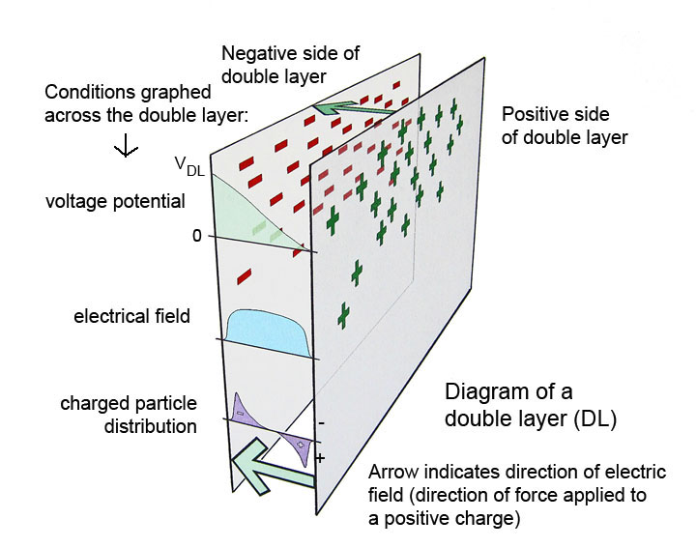
Figure 1. An electric double layer is illustrated with positive and negative charges, a potential difference, an electric field, and the corresponding charge distribution.
When an electric double layer forms, a strong potential difference and electric field develop between the layers [5]. These structures are commonly identified through their electrical characteristics, both in laboratory environments and in nature. Such structures can also be observed in Earth's magnetosphere, although their intensities and formation mechanisms vary. From the outset, Alfvén considered this large-scale structure suitable for explaining magnetospheric behavior [6]. Later, Clarage, in his proposal, introduced a well-defined electric structure in the Earth's radiation belt region that closely matched the characteristics of an electric double layer. [7]
Research by Peratt and Alfvén focused on comparing electric double layers created in terrestrial laboratories with data obtained from near-Earth plasma, largely consistent with measurements from the GEOS and ISEE satellites. These satellites were the first to transmit plasma data from Earth's vicinity and were equipped with electric field detectors (Figure 2) [6, 8].
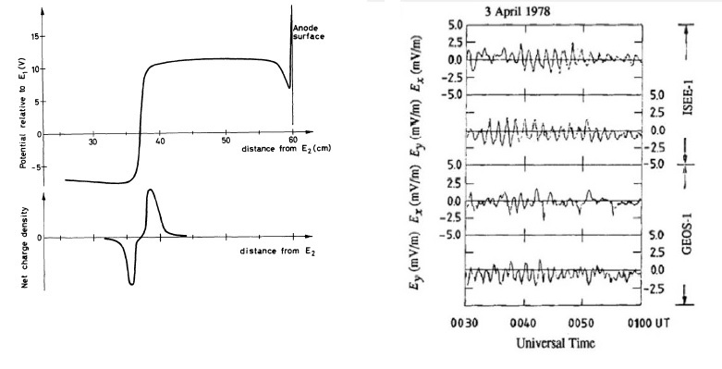
Figure 2. Right: Data from the GEOS-1 and ISEE-1 satellites showing the electric field in different directions [9]. Left: Laboratory plasma double layer, illustrating the potential and current components [10].
The essential conditions for identifying electric double layers are summarized as follows:
1. Sudden Jump in Electric Potential (ϕ)
In an electric double layer, the electric potential changes abruptly over a very short distance. This change can range from a few volts to several hundred volts.
Δϕ=−∫​​Edx
2. Strong Electric Field (E):
This sudden change in potential creates a strong electric field, typically in the direction opposite to the potential gradient (E=−∇ϕ)
3. The electric double layer arises due to the difference in the density of charged particles (electrons and
ions),leadingtoasudden jumpinpotential.
4. Theelectricfieldinthisregionisstrong anddirectlyrelatedtothegradientofthepotential.
5. The direction of the electric field depends on the variations in potential; if the potential increases in the
positivedirection,thefieldchangesinthenegativedirection,andviceversa

Observation of electric double layers in the radiation belt region during solar storms
To analyze the electric field data, measurements from the Van Allen Belts and RBSP satellites were employed. While the numerical data are publicly available through NASA’s online database [11], direct use of the raw data is inadequate for detailed analysis. The data are also accessible in graphical form with basic calibration via the University of Minnesota website [12]; however, this calibration does not provide the accuracy required to examine the electric double layer structure through field and potential difference measurements. Consequently, the numerical data were recalibrated using our methodology.
The Fast Fourier Transform (FFT) was applied to effectively remove noise from the dataset. Vector components affected by unidentified noise were corrected using the Savitzky-Golay (SavGol) algorithm implemented in Python, eliminating spurious values while preserving relevant signal features. Finally, by rescaling the resulting graphs in accordance with the timing of solar storms in 2015, the characteristic patterns of the electric double layer structure during these events were successfully extracted.
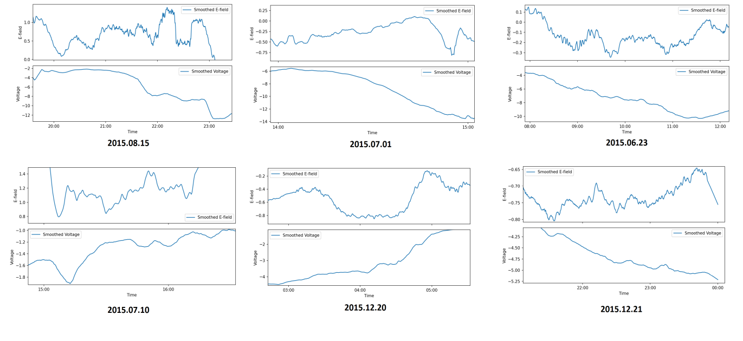Figure 3. Electric field and potential difference data from the radiation belts on selected days during the solar storms of 2015.
Analysis of the data reveals that the pattern of the electric structure is consistently observed in the radiation belt region during all solar storm events. In line with the definition of an electric double layer, abrupt changes in the potential difference—whether increases or decreases—cause the electric field to shift from its original position, reflecting these rapid fluctuations. Once the changes in potential difference subside, the electric field returns to its initial state. This dynamic behavior was consistently observed across all types of solar storms in 2015, with the six graphs presented here serving as representative examples.
Conclusion
In this study, we analyzed the electric potential and potential difference data obtained from the EFW probe during geomagnetic storms, applying the Fast Fourier Transform (FFT) to effectively reduce noise. Our results demonstrate that electric double layer structures can be reliably observed in the radiation belt region during solar storm events using electric field and potential difference measurements. These observations confirm the existence and detectability of such structures on a smaller scale and provide valuable insight into the dynamic behavior of the magnetospheric plasma under disturbed conditions.
Importantly, the methodology employed in this work establishes a robust foundation for future investigations. By extending the analysis to include particle distribution and density data, as well as detailed satellite position tracking, it will be possible to explore whether these double layer structures persist on larger spatial scales and under different geomagnetic conditions. This approach will allow for a more comprehensive understanding of the formation, evolution, and stability of large-scale electric structures in the Earth's magnetosphere.
Furthermore, our study highlights the potential for systematic identification of electric double layers during a wide range of solar and geomagnetic events. By integrating additional datasets and refining calibration and noise reduction techniques, future research can not only verify the presence of larger or more persistent structures but also characterize their spatial and temporal evolution in unprecedented detail.
Overall, this work demonstrates that the approach presented here provides a solid and scalable framework for advancing research in magnetospheric plasma physics. The findings not only validate the detectability of electric double layers under specific storm conditions but also open the door to future studies aimed at mapping these structures on broader scales, thereby offering a pathway for more detailed assessments of their role in magnetospheric dynamics. In essence, this study lays the groundwork for a long-term research program that can systematically explore the prevalence, characteristics, and implications of electric double layer structures in Earth's radiation belts.
Acknowledgments
This study was conducted based on the proposal introduced by Michael Clarage and continued as part of the master’s thesis work of Mohammad Reza Shafizadeh at the University of Zanjan (ZNU), under the supervision of Dr. Yusefali Abedini and with consultation from Dr. Michael Clarage.

References
- Block, L. P. 1978, A double layer review, Astrophysics and Space Science, vol. 55, no. 1, May 1978, p. 59-83
- H. Alfven; Aug 1977; “Electric Currents in Cosmic Plasmas”, Review of Geophysics
- P. Carqvist; Oct 1989; “On The Physics Of Relativistic Double Layers”, Astrophysics and Space Sciences; p23
- J. Johnson; Aug 2011; “The Essential Guide To The Electric Universe”, chapter 5, Tbolts inc
- Joos, G; 1951; Theoretical Physics. London & Glasgow: Blackie & Son Ltd. p. 271
- H. Alfven; 1986; “Double Layers and Circuits in Astrophysics”, NASA-CR-180018, NAS 1.26:180018, TRITA-EPP-86-04
- M. Clarage; Larger Electric Structures Around Earth and Sun, Proposal For Study 2014. Researchgate
- A. Peratt; 2015; Physics of The Plasma Universe, ISBN 978-1-4614-7818-8
- Torven, S. and Lindberg; 1980 Properties of a fluctuating double layer in a magnetised plasma column, Journal of Physics D: Applied Physics
- Falthammar, C.-G; 1978; Generation mechanisms for magnetic-field-aligned electric fields in the magnetosphere, Geoelectr. 30, 419
- Science Operations Center, University of California, Berkeley Space Sciences Laboratory, NASA
- RBSP/EFW Home – University of Minnesota- Institute for Astrophysics- Radiation Belt Strom Probes Data
- Large Electrical Structures In Interplanetary Space And Planetary Magnetospheres. M.R. Shafizadeh, Y. Abedini, M. Clarage. Master’s Thesis, University of Zanjan, Iran. Feb 2019

Исследование крупномасштабных электрических структур в радиационных поясах Земли во время геомагнитных бурь с использованием данных о электрическом поле и разности потенциалов со спутников RBSP
Мохаммад Реза Шафизаде¹, Бехнам Бабаеиан²
¹Магистр, ранее в Университете Занджана, факультет физики, Иран, [shafizadeh@alumni.znu.ac.ir]
²Университет Фридриха-Александра Эрлангена-Нюрнберга, Германия
Аннотация. В этом исследовании изучаются крупномасштабные электрические структуры в радиационных поясах Земли во время геомагнитных бурь. Основная цель заключается в выявлении и характеристике крупномасштабных электрических двойных слоев в околоземном космическом пространстве. Мы предполагаем, что такие структуры могут существовать вокруг Земли постоянно, и данное исследование является важным шагом к пониманию их формирования и поведения в условиях экстремальной солнечной активности. Используя данные о электрическом поле и разности потенциалов, полученные инструментом EFW (Electric Field and Waves) на борту спутников RBSP (Van Allen Probes), мы проанализировали периоды интенсивных геомагнитных бурь. Данные были обработаны с применением преобразования Фурье (FFT) для снижения шума и выявления крупномасштабных структур двойных слоев. Наши результаты демонстрируют наличие крупномасштабных электрических двойных слоев в радиационных поясах во время геомагнитных бурь. Эти результаты создают основу для будущих исследований, в рамках которых мы планируем изучить, существуют ли эти структуры постоянно в околоземном космическом пространстве, даже в периоды спокойной солнечной активности. Данное исследование способствует более глубокому пониманию электрических структур в космосе и их влияния на динамику космической погоды.

