SUPERSUBSTORMS and GEOMAGNETICALLY INDUCED CURRENTS ON 10 MAY 2024

I.V. Despirak¹, P.V. Setsko¹, A.A. Lubchich¹, Ya.A. Sakharov¹, V.N. Selivanov²

¹Polar Geophysical Institute, Apatity, Russia; e-mail: despirak@gmail.com
²Northern Energetic Research Center, Kola Scientific Centre RAS, Apatity, Russia

Abstract. Very strong magnetic storm (superstorm) with Kp = 9 and Dst = -406 nT occurred on 10-13 May 2024. The superstorm was characterized by a gradual, three-step main phase development with maximum at ~ 02:14 UT on 11 May (SYM/H = -518 nT), and the prolonged recovery phase until May 13. At the background of the storm additional geomagnetic activities were also registered – intense substorms and geomagnetic pulsations. Recent studies have shown that substorms development was main source of intense geomagnetically induced currents (GICs) occurred in the night sector, whereas Pi3/Pc5 geomagnetic pulsations were primary sources of intense GICs in the morning sector. Besides, extremely intense geomagnetic disturbances, so-called supersubstorms (SSSs: SML<−2500 nT), were recorded during the main phase of the May storm: at ~19:20 UT, ~19:50 UT and ~ 22:40 UT on 10 May 2024. The aim of this study is to analyze the enhancement of GICs in electrical circuits in the northwest of Russia during supersubstorms recorded at the main phase on 10 May 2024. The appearance of GICs were monitored using data from stations Vykhodnoy (VKH), Loukhi (LKH) and Kondopoga (KND) in the northwestern Russia (PGI, EURISGIC, eurisgic.ru). The planetary spatiotemporal distribution of the magnetic disturbances was examined using data from ground-based magnetometer networks (SuperMAG and IMAGE) as well as the magnetic field measurements from the Iridium constellation of 66 satellites at an altitude of ~780 km, distributed over six orbital planes equally spaced in longitude (AMPERE project). The fine spatiotemporal structure of electrojet development during the supersubstorms was investigated using latitudinal profiles of the equivalent currents derived from MIRACLE system. It was shown that extremely intense GICs were not recorded during supersubstorms, despite the fact that the GIC measurement stations were located in night sector at this time. Possible reasons for the absence of strong GICs in electrical circuits in the northwest of Russia during the development of the supersubstorms on May 10 2024 are discussed.

Introduction
Traditionally, geomagnetically induced currents (GICs) are considered intense, low-frequency (~0.001–1 Hz), quasi-direct currents in terrestrial technological networks, induced by electric fields generated by any rapid changes in the magnetic field during various space weather events (e.g. [Oliveira and Ngwira, 2017; Viljanen and Pirjola, 2017; Lakhina et al., 2021]). These induced electric fields arise when strong magnetospheric disturbances occur due to rapid changes in the magnetic field (dB/dt) (e.g. [Boteler and Jansen van Beek, 1999]) and can be caused by various current system that develop in magnetosphere, such as a sharp increase in the ring current, intensification of auroral electrojets, or the generation of low-frequency pulsations [Boteler and Jansen van Beek, 1999; Despirak et al., 2022a; Yagova et al., 2021; Setsko et al., 2023].
Since 2011, a system for measuring GICs has been established and operational in northwestern Russia. This system measures GIC in the solidly grounded neutral wire of autotransformers in the existing Karelian-Kola power transmission line. GIC measurement sensors are mounted on grounded neutral wire of Y - type autotransformers at the 330 kV line at 5 substations located at geographic latitudes from ~ 60° to ~ 69° N (geomagnetic latitudes from ~ 57.3° to ~ 65.5° MLAT). These correspond to auroral and subauroral latitudes, where substorms typically develop [Sakharov et al., 2007; 2016; Selivanov et al., 2023]. Recently it has been established that the intensification and poleward movement of the westward electrojet during substorm expansion phases are main sources of intense GICs occurring in the night sector, while Pi3/Pc5 geomagnetic pulsations are main sources of intense GIC in the morning sector [Despirak et al., 2022a, 2023, 2024; Setsko et al., 2023]. Despite the large number of studies devoted to the analysis of GICs, further studies of intense GICs during various space weather events and their comparison are required to better understand their geophysical sources and to predict their occurrence.
The aim of this study is to conduct the analysis of the increase of GIC during superstorm on 10-12 May 2024, namely on 10 May, at the main phase of the storm, when very intense substorms, so called supersubstorms (SSS), were observed. The term “supersubstorms” was first introduced by Tsurutani et al. [2015] to describe extremely intense magnetic substorms identified from SuperMag magnetometers network, corresponding to events with SML index values lower than -2500 nT. To date, several studies have investigated the statistical occurrence of supersubstorms and their dependence on solar activity, interplanerary magnetic field (IMF) and solar wind conditions, and the presence of magnetic storms [Haira et al., 2016; Despirak et al., 2019]. The energy characteristics of supersubstorms [Tsurutani and Haira, 2023] and a detailed case studies of individual events [Despirak et al., 2020, 2022b] have also been reported.
Figure 1 shows the variations of SML index from 18:36 UT on 10 May to ~14:36 UT on 11 May. Four periods of extremely negative values of SML index (SSSs) were recorded during the storm. Two SSS events occurred at ~19:20 and ~19:50 UT, and another at ~ 22:40 UT on 10 May 2024, during the main storm phase. Two more SSS events developed at ~08:50 and ~09:50 UT, and ~ 12:45 and 13:30 UT on 11 May 2024, during the recovery storm phase. In this study, we analyze the enhancement of GIC in electrical circuits in the northwest Russia during two SSSs observed at the main phase at ~19:20, ~19:50 UT, and ~ 22:40 UT on 10 May 2024, when GICs measurement stations and IMAGE chain were located in the night sector.
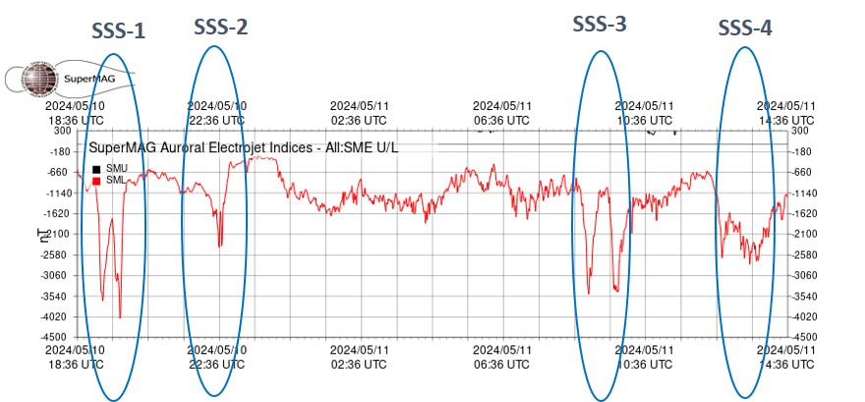
Figure 1. Variations of the geomagnetic index SML from 18:36 UT on 10 May to 14:36 UT on 11 May 2024. Four periods of the supersubstorms are shown by the blue ovals.

Data
We used data from the system to measure GICs in the existing Karelian-Kola power transmission line with a length of over 800 km in northwestern Russia (http://eurisgic.ru). The system includes five stations: Vykhodnoy (VKH), Revda (RVD), Titan (TTN) (Murmansk region), Loukhi (LKH) and Kondopoga (KND) (Republic of Karelia). Geographic/geomagnetic coordinates of the stations, the data of which were available in present study: Vykhodnoy (VKH; 68.8° N, 33.1° E / 65.53° MLAT, 112.73° MLONG), Loukhi (LKH; 66.08° N, 33.12° E / 63.02° MLAT, 110.57° MLONG) and Kondopoga (KND; 62.2° N, 34.3°E / 59.11° MLAT, 110.10° MLONG). Each substation is equipped with Hall sensors that directly measure the currents flowing into the ground through the grounded neutral wire of autotransformers. Positive values mean GICs are going into the ground (Selivanov et al., 2023). The main part of the 330 kV transmission line is oriented from south to north, almost along the meridian, and all substations are solidly grounded. The spatial distribution of the substorm was determined using the magnetometers data from IMAGE (http://space.fmi.fi/image/) and SuperMAG (http://supermag.jhuapl.edu/) networks. The SML- index was also obtained from SuperMAG database. To examine the spatial distribution of magnetic disturbances along the IMAGE meridian, instantaneous maps of ionospheric equivalent currents from MIRACLE (https://space.fmi.fi/MIRACLE/) were analyzed.

Results
1. First period: SSS-1
The magnetic disturbances and GIС measurements for the first period from 17 to 24 UT on 10 May are shown in Figure 2. The SSS-1 time period shown by blue oval. Accordingly SuperMAG map, strong magnetic disturbances were registered only in the morning and daytime MLT sectors over Alaska; no strong magnetic disturbances were observed in the nighttime and evening sectors (Figure 2e). This is also confirmed by the AMPERE magnetic vector map, which shows the development of a large-scale ionospheric vortex rotating clockwise in the morning sector (Figure 2f). This vortex is shifted toward the daytime sector, such that no magnetic disturbances were observed over the IMAGE chain and GIC recording stations during the development of the SSS-1.
According to variations in the X- and Y-components of the IMAGE magnetometers from Polesie (PPN) to Ny-Ålesund (NAL), no magnetic disturbances were recorded at auroral latitudes (Figure 2c and 2d). Negative bays of ~300 nT were observed only at high latitudes from stations BJN to NAL. Below these stations, disturbances were insignificant. According to MIRACLE map, the westward electrojet was registered only at high latitudes, higher than the VKH, LKH, KND stations are located (Figure 2a) and, accordingly, no GICs was recorded at stations VKH, LKH, and KND (Figure 2b).
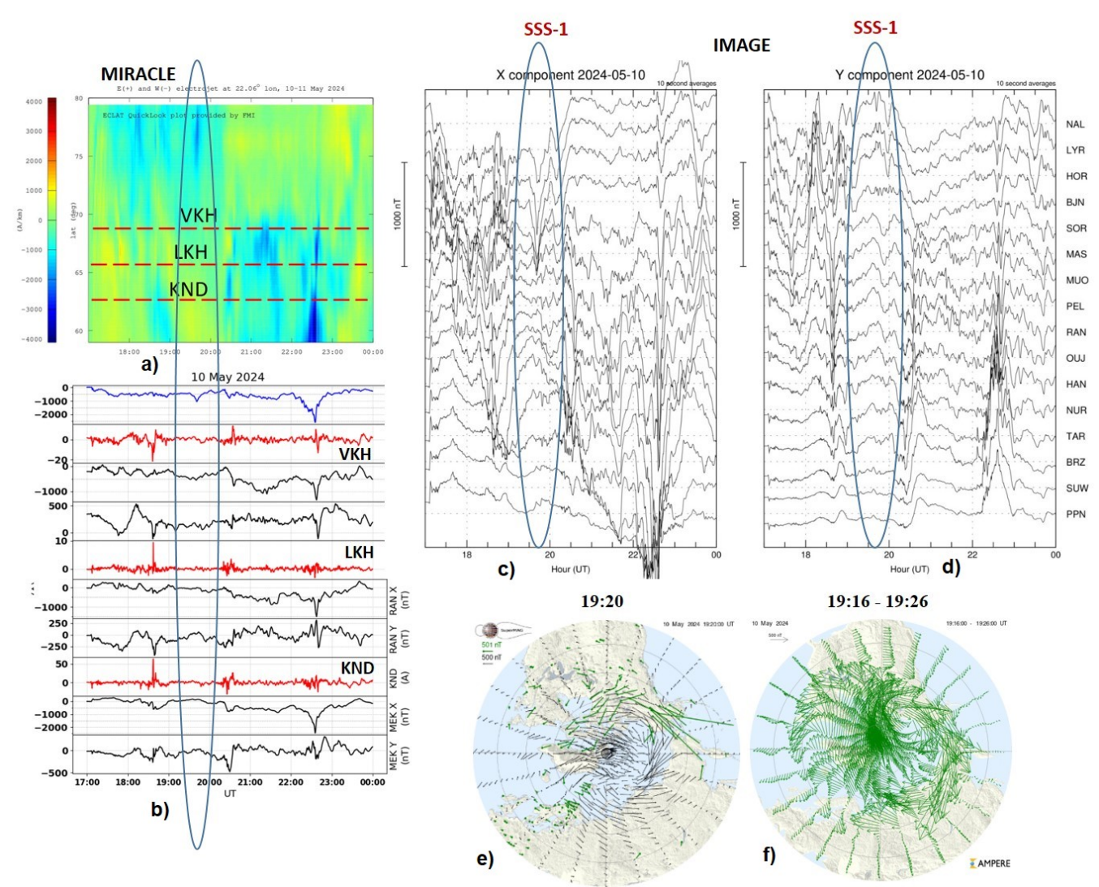

Figure 2. May 10, 2024 from 17 to 24 UT, blue ovals shown the First period for the study: the map of westward and eastward latitudinal profile of the electrojets, calculated by the MIRACLE system (a); GIC profiles (red lines) located between corresponding latitudes of the IMAGE stations (b); X- and Y components of geomagnetic field from IMAGE magnetometers (chain PPN-NAL) (c, d); maps of magnetic vectors from SuperMag network (e) and AMPERE map of the spherical harmonic analysis of magnetic disturbances for the moments corresponding the moment of the maximum of SSS-1: 19:16-19:26 UT (f).

2. Second period: SSS-2
Figure 3 shows the magnetic disturbances and GIС measurements for the period of second supersubstorm (SSS-2); SSS- 2-time period shown by blue oval. Format of the Figure 3 is the same as Figure 2. Accordingly SuperMAG and AMPERE maps, the distribution of the magnetic disturbances is different than for SSS-1. It is seen the strong and extended in latitudes westward electrojet observed in post-midnight sector, where IMAGE and GICs registration stations were located (Figure 3e and 3f). The magnetic disturbances ~ -500-2000 nT were recorded from PPN to NAL ~51.4° – ~78.9° Geogr. Lat., but due to the strong equatorward shift the strongest ~ -2000 nT of these were observed at the low-latitude stations of the chain from PPN to NUR (Figure 3c and 3d). Figure 3f demonstrated the distributions of magnetic disturbances by AMPERE data: the clockwise vortex of the magnetic vectors in morning – day sector, but additionally the very intense westward electrojet extended in longitudes: from the morning (~10 MLT) to the pre-midnight sector (~22 MLT); the strongest disturbances (~ -2500 nT) were recorded at stations in Alaska (magnetograms not shown here). Maximum of SSS-2 developed in Alaska sector, but the strong westward electrojet propagated to the West and reach the midnight sector with strongest disturbances at the subauroral and midlatitudes. Thus, at the IMAGE chain were recorded only the polar edge of SSS-2 caused the intense GICs occurred at VKH ~ 12A, LKH ~5A and KND ~25A. It was in accordance with the development of the westward electrojet according to the MIRACLE map (Figure 3a).

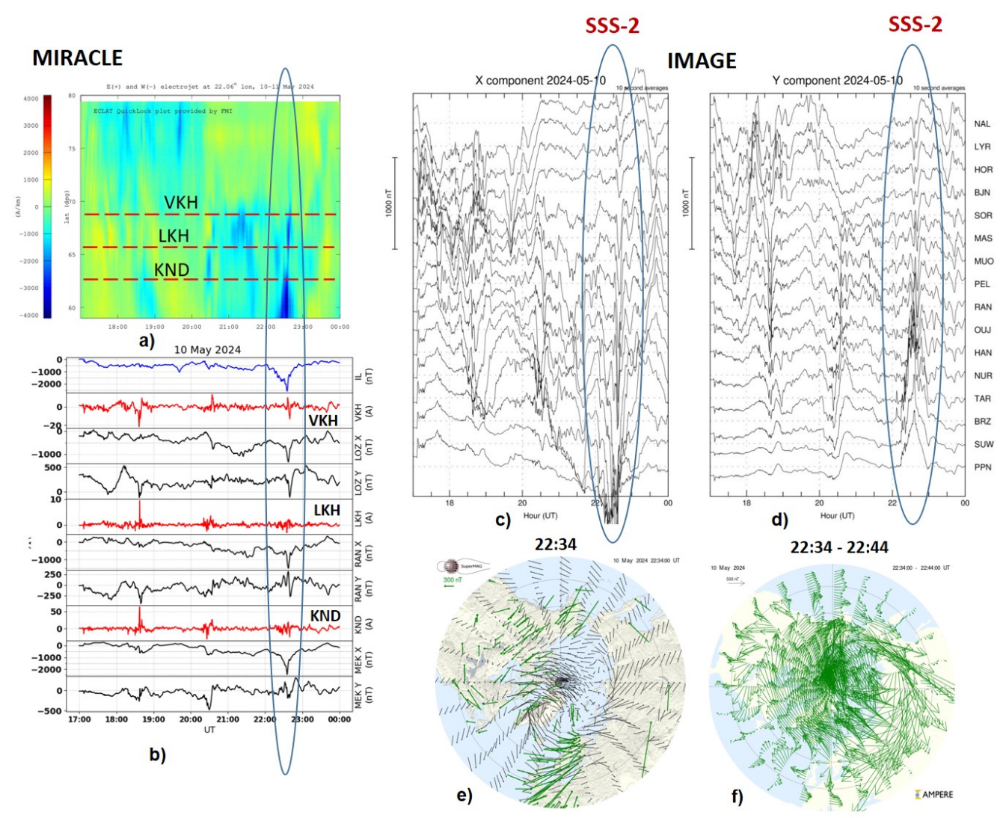

Figure 3. Second period in more details, from 17 to 24 UT 10 May 2024. Format Fig.3 is the same as Fig.2.

Conclusions
The enhancement of GICs in electrical circuits in the northwest Russia during two supersubstorms during the main phase of superstorm on 10 May 2024 were analyzed. No direct relationship was found between SSS development and occurrence of intense GIСs. Of two SSS events, only SSS-2 was accompanied by intense GIСs. The initial phase of the storm was characterized by the formation of an intense magnetic vortex in the morning – day sector over the Pacific Ocean, which led to the absence of GIC during SSS-1. The intense GICs in the northwest Russia recorded during SSS-2 were connected to the polar edge of the westward electrojet developed during SSS-2.

Acknowlegments
The authors gratefully acknowledge the SuperMAG (http://supermag.jhuapl.edu/), AMPERE (http://ampere.jhuapl.edu), and EURISGIC (https://eurisgic.org/) teams for providing access to their data and tools used in this study.

References
Boteler D.H., Jansen van Beek G. (1999) August 4, 1972 revisited: A new look at the geomagnetic disturbance that caused the L4 cable system outage. Geophysical Research Letters, V. 26, Is. 5, P. 577–580. https://doi.org/10.1029/1999GL900035
Despirak I.V., Lyubchich A.A., Kleimenova N.G. (2019) Supersubstorms and conditions in the solar wind. Geomagnetism and Aeronomy, V. 59, No. 2, P. 170-176. https://doi.org/10.1134/S0016793219020075
Despirak I.V., Kleimenova N.G., Gromova L.I., Gromov S.V., Malysheva L.M. (2020) Supersubstorms during storms of September 7–8, 2017. Geomagnetism and Aeronomy, V. 60, No. 3, P. 292-300. https://doi.org/10.1134/S0016793220030044
Despirak I.V., Setsko P.V., Sakharov Ya.A., Lyubchich A.A., Selivanov V.N., Valev D. (2022a) Observations of geomagnetic induced currents in Northwestern Russia: case studies. Geomagnetism and Aeronomy, V. 62, No. 6, P. 711–723. https://doi.org/10.1134/S0016793222060032
Despirak I.V., Kleimenova N.G., Lyubchich A.A., Setsko P.V., Gromova L.I., Werner R. (2022b) Global Development of the Supersubstorm of May 28, 2011. Geomagnetism and Aeronomy., V. 62, No. 3, P. 199-208. DOI: 10.1134/S0016793222030069
Despirak I.V., Setsko P.V., Sakharov Ya.A., Lubchich A.A., Selivanov V.N. (2023) Geomagnetically induced currents during supersubstorms on September 7-8, 2017. Bulletin of the Russian Academy of Sciences: Physics, V. 87, P. 999–1006. https://doi.org/10.3103/S1062873823702283
Despirak I., Setsko P., Lubchich A., Hajra R., Sakharov Ya., Lakhina G., Selivanov V., Tsurutani B.T. (2024) Geomagnetically induced currents (GICs) during strong geomagnetic activity (storms, substorms, and magnetic pulsations) on 23–24 April 2023. J. Atm. Solar-Terr. Phys., V. 261, Art. 106293. https://doi.org/10.1016/j.jastp.2024.106293
Hajra R., Tsurutani B.T., Echer E., Gonzalez W.D., Gjerloev J.W. (2016) Supersubstorms (SML < -2500 nT): Magnetic storm and solar cycle dependences. J. Geophys. Res. Space Physics, V. 121, Is. 8, P. 7805–7816. https://doi.org/10.1002/2015JA021835
Lakhina G.S., Hajra R., Tsurutani B.T. (2021) Geomagnetically induced currents. In H.K. Gupta (Ed.), Encyclopedia of solid earth geophysics (pp. 523–527). Cham: Pringer International Publishing. https://doi.org/10.1007/978-3-030-58631-7_245
Oliveira D.M., Ngwira C.M. (2017) Geomagnetically induced currents: Principles. Braz. J. Phys., V. 47, P. 552–560. https://doi.org/10.1007/s13538-017-0523-y
Sakharov Ya.A., Danilin A.N., Ostafiichuk R.M. (2007) Recording of GICs in power systems of the Kola Peninsula, in Trudy 7-go Mezhdunar. simp. po elektromagnitnoi sovmestimosti i elektromagnitnoi ekologii (Proceedings of the 7th International Symposium on Electromagnetic Compatibility and Electromagnetic Ecology), St. Petersburg: IEEE, pp. 291–293.
Sakharov Ya.A., Katkalov Yu.V., Selivanov V.N.,Viljanen A. (2016) Recording of GICs in a regional power system, in Prakticheskie aspekty geliogeofiziki, Materialy spetsial'noi sektsii "Prakticheskie aspekty nauki kosmicheskoi pogody" 11-i ezhegodnoi konferentsii "Fizika plazmy v solnechnoi sisteme" (Practical Aspects of Heliogeophysics: Proceedings of the Special Section "Practical Aspects of the Science of Space Weather" of the 11th Annual Conference "Physics of Plasma in the Solar System"), Moscow. IKI, pp. 134–145.
Selivanov V.N., Aksenovich T.V., Bilin V.A., Kolobov V.V., Sakharov Y.A. (2023) Database of geomagnetically induced currents in the main transmission line “Northern transit”. Solar- Terr. Phys., V. 9, № 3, Art. 93101. https://doi.org/10.12737/stp-93202311
Setsko P.V., Despirak I.V., Sakharov Ya.A., Lubchich A.A., Bilin V.A., Selivanov V.N. (2023) Geoinduced currents on Karelian-Kola power line and Finnish gas pipeline on September, 12–13 2017. J. Atm. Solar-Terr. Phys., V. 247, Art. 106079. https://doi.org/10.1016/j.jastp.2023.106079
Tsurutani, B.T., Hajra, R., Echer, E., Gjerloev, J.W. (2015) Extremely intense (SML ≤ –2500 nT) substorms: Isolated events that are externally triggered? Ann. Geophys., V. 33, P. 519–524. https://doi.org/10.5194/angeo-33-519-2015
Tsurutani B.T., Hajra R. (2023) Energetics of Shock-triggered Supersubstorms (SML < −2500 nT). The Astrophysical Journal, V. 946, No. 1. https://doi.org/10.3847/1538-4357/acb143
Viljanen A., Pirjola R. (2017) Influence of spatial variations of the geoelectric field on geomagnetically induced currents. J. Space Weather Space Clim., V. 7, Art. A22. https://doi:10.1051/swsc/2017024
Yagova N.V., Pilipenko V.A., Sakharov Ya.A., Selivanov V.N. (2021) Spatial scale of geomagnetic Pc5/Pi3 pulsations as a factor of their efficiency in generation of geomagnetically induced currents. Earth, Planets and Space, V. 73, Art. 88. https://doi.org/10.1186/s40623-021-01407-2

геоиндуцированные токи во время умеренной магнитной бури 12-13 сентября 2017

И.В. Дэспирак¹, П.В. Сецко¹, А.А. Любчич¹, Я.А. Сахаров¹, В.Н. Селиванов²

¹Полярный геофизический институт, Апатиты, Россия, despirak@gmail.com;
²Центр физико-технических проблем Севера, Кольский научный центр РАН, Апатиты, Россия

Абстракт
Сложный комплекс явлений космической погоды в сентябре 2017 г. включал в себя разные явления: межпланетные корональные выбросы массы (ICME), магнитные облака (МО), SHEATH и CIR области, высокоскоростные потоки солнечного ветра (HSS), быстрые ударные волны. В этом отчете мы рассмотрим геомагнитную активность и появление геоиндуцированных токов (ГИТ) во время умеренной магнитной бури (SYM/H ~ -65 нТл), произошедшей 12-13 сентября и вызванной ММП южного направления во время SHEATH. Известно, что одним из важных источников ГИТ в авроральной зоне является усиление и движение электроджетов во время суббурь. На фоне бури 12-13 сентября 2017 г. были зарегистрированы две интенсивные суббури (SML~1070 и ~1540 нТл). Мы проанализировали тонкую пространственно-временную структуру развития электроджетов во время суббурь, используя широтные профили эквивалентных токов системы MIRACLE и данные магнитометров IMAGE. Появление ГИТ контролировалось по данным российских станций Выходной (VKH) и Кондопога (KND) (PGI, EURISGIC, eurisgic.ru) на Северо-Западе России (eurisgic.ru) и станции Мантсала (MAN) на юге Финляндии. Показано, что появление ГИТ на разных широтах связано с движением западного электроджета к полюсу во время фазы расширения суббури. Кроме того, установлено, что источником одного из всплесков ГИТ был короткий импульс пульсаций Рс5 на восстановительной фазе интенсивной суббури. В работе также показана связь увеличения геомагнитных индексов IL и Wp с появлением ГИТ, что также указывает на зависимость появления ГИТ от суббуревой активности.

E-mails:
И.В. Дэспирак despirak@gmail.com
П.В. Сецко setsko@pgia.ru
А.А. Любчич lubchich@pgia.ru
Я.А. Сахаров sakharov@pgia.ru
В.Н. Селиванов v.selivanov@ksc.ru

