AN ANALYSIS OF ENERGETIC PROTON FLUXES BELOW THE INNER RB AT THE EARLY STAGE OF RING CURRENT DEVELOPMENT DURING THE MAY 2024 SUPERSTORM

A. V. Suvorova

D.V. Skobeltsyn Institute of Nuclear Physics M.V. Lomonosov Moscow State University, Moscow, Russia
alla_suvorova@mail.ru

Abstract. The sudden increase in the fluxes of energetic (30-300 keV) electrons below the Earth’s inner radiation belt (RB), known as forbidden energetic electrons (FEE), has been systematically studied over the past decade. A mechanism of fast radial transport was proposed to explain this phenomenon, the essence of which is electric drift independent of the sign of the particle charge. Leaving aside for now the issues related to the nature of origin or penetration of the electric field into such low L shells, it should be noted that it was not possible to detect unambiguous signs of an increase in energetic proton fluxes. A number of factors could have influenced the failures of previous efforts. In particular, injected protons and electrons drift in opposite azimuthal directions, and the ring current protons penetrate to low altitudes everywhere during the storm main phase. In this paper, we analyze the spatiotemporal characteristics of increases in proton flux intensities at early stage of the magnetic storm in May 2024 when the FEE event was also observed. We found evidence of proton injection, confirming the E✕B drift.

Introduction
The intensity of the fluxes of trapped particles in the Earth's inner RB drops sharply at its inner edge, which is located on the drift shell L~1.2. The region below the inner edge of the RB (L< 1.2) is called the forbidden zone. The background fluxes of energetic (up to several hundred keV) electrons and protons in the forbidden zone do not exceed 10² particles per (cm² s sr) under quiet geomagnetic conditions [1,2]. The inner RB edge is formed at altitudes where particle losses become significant due to effective scattering in the dense atmosphere, as well as due to the presence of a region of weak magnetic field in the South Atlantic Anomaly (SAA). Sudden flux increases of energetic electrons, called FEE event, are sometimes observed in the forbidden zone.
Continuous measurements (since 1998) of energetic particle fluxes by the NOAA/POES low-orbit (~850 km) satellites were used to create a catalog of anomalous events with FEE-flux increases [3]. The FEEs constitute a quasi-trapped population, which is characterized by the short lifetime, one azimuthal drift period, which depends on the sort and energy of particles (it is hours for keV energy range) [4]. A possible mechanism, electric drift, for the FEE phenomenon was proposed in [5]. Recently, key parameters of a mechanism was inferred from the analysis of several superstorms [6]. The electric drift mechanism implies a fast transport (injection) of particles. The source of injected particles is the inner RB [7]. The source of the electric field is currently unknown and under discussion [8, 9]. The particles injection occurs as a result of radial drift in the E✕B fields, which does not dependent from the sign of the particle charge. However, no simultaneous increases of keV-energy proton fluxes were observed and reported. There may be several reasons for the the low probability to detect electrons and protons simultaneously in the forbidden zone by one satellite: (1) in the nonuniform geomagnetic field, protons and electrons experience gradient drift in opposite azimuthal directions; (2) a relatively low flux of keV protons in the quiet RB; (3) high proton fluxes of the storm ring current, quickly and widely penetrating to low altitudes; (4) effective losses of low-energy protons in the charge-exchange process; (5) the influence of South Atlantic Anomaly (SAA), which occupies a vast longitudinal area.
In this paper, we consider the dynamics of proton fluxes associated with the FEE-event during the superstorm in May 2024. We analyze the spatio-temporal characteristics of increases in proton flux intensities at early stage of the storm main phase when the asymmetric ring current was developing.

Data
We use measurements of energetic particles fluxes from the MEPED instruments on board the NOAA/POES and MetOp satellites. The MEPED telescope includes detectors of electrons and protons with energy in the keV and MeV ranges with two orthogonal orientations: vertical (0°-detector) and horizontal (90°-detector). The 0°-detector measures quasi-trapped particles at the equator and precipitating particles at high-latitudes, while the 90°-detector - vice versa. We use the data on >30 keV protons and electrons.

Results
The radial transport mechanism involves both energetic electrons and protons. Previous analysis showed that the electron fluxes (FEE event) enhanced during this storm [4]. It was found that the first electron injection occurred about 19:20 UT, more than 2 hours after SSC (~17:06 UT), during the main phase on 10 May 2024. The main phase developed from 18 UT on 10 May until 02:20 UT on 11 May, reaching a maximum storm index of SYM-H = -512 nT. The solar wind pressure stayed strong and exhibited several sharp large increases and decreases which were manifested in corresponding variations of SYM-H index [4, see for details]. The present study is focused on dynamics of the >30 keV quasi-trapped protons during the beginning of the superstorm on 10 May 2024 in order to find out the time of their possible injection.
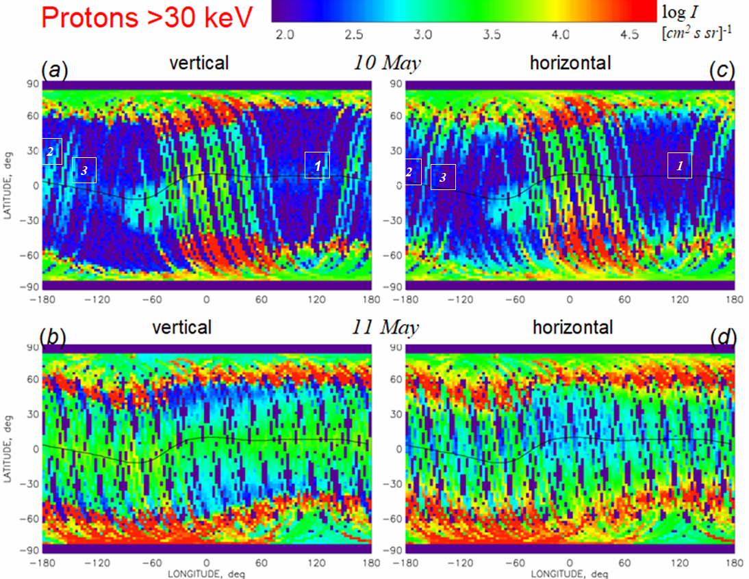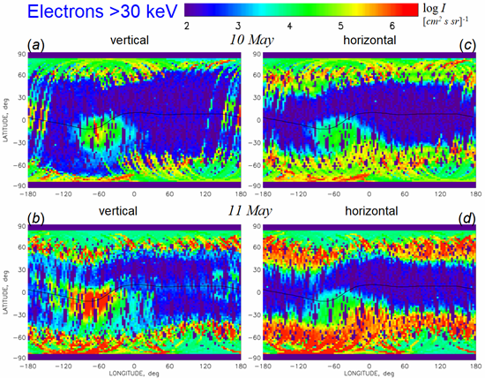
Figure 1. Geographic maps of maximal >30 keV proton fluxes during storm days May 10 and 11, 2024. Measurements of vertical detector (a,b) and horizontal detector (c,d). The black curve indicates the dip equator. Numbers 1-3 indicate tracks with pitch-angle anisotropy. | Figure 2. Geographic maps of maximal >30 keV electron fluxes during storm days May 10 and 11, 2024. Measurements of vertical detector (a,b) and horizontal detector (c,d). The black curve indicates the dip equator.  FEE enhancements are observed by vertical detectors.
Fig. 1 and Fig. 2 show global maps of fluxes of protons and electrons with the energy >30 keV during two storm days 10-11 May. During the storm, the forbidden zone at low latitudes was temporally populated by energetic electrons and protons, but behavior of protons and electrons at low latitudes is different. The forbidden zone extends in ~20° vicinity of the dip equator excepting the region of South Atlantic Anomaly (SAA) located in the longitudinal sector from 100°W to 0°E. Quasi-trapped electrons (Fig. 2a,b) enhanced in the forbidden zone (FEE event) west of SAA, in particular at the the equator, whereas precipitating electrons (Fig. 2c,d) did not. Both quasi-trapped and precipitating protons fluxes enhanced over a wide range of latitudes (Fig. 1a,c) east of SAA, finally occupying all longitudes on 11 May (Fig. 1b,d). Thus, the key feature of the FEE event is an anisotropic flux in pitch-angle distribution. Protons exhibit an isotropic pitch-angle distribution, which is the main characteristics of storm ring current development. However, some tracks show evidence of anisotropic flux on 10 May (numbers 1-3 in Fig.1a,c).
Table 1. First injection of energetic particles below the inner ERB
SC | LT | Time | Long φ° | Je, (cm²s sr)⁻¹  >40 keV | Je, (cm²s sr)⁻¹  >130 keV | Jp, (cm²s sr)⁻¹  >30 keV | L
P8 | 10.5 | 19:00 | -127 | - | - | 5E1 | 1.13
P3 | 9 | 19:12 | -147 | - | - | 6E1 | 1.12
P9 | 9 | 19:22 | -153 | 7E4 | 5E4 | 5E1 | 1.11
P5 | 7 | 19:37 | +177 | 3E6 | 1E6 | 5E1 | 1.10
In Fig. 1a (tracks no.2 and no.3) and Table 1, moderately enhanced fluxes ~50 (cm² s sr)⁻¹ of >30 keV protons occurred in ~20° vicinity of the dip equator above Pacific in the longitudinal sector from 170°E to 127°W at drift shells L < 1.13. We choose this interval of longitudes for further analysis of pitch-angle asymmetry. The enhancements in this region were observed by three POES satellites in the prenoon sector from 17 to 21 UT (Fig.3). The satellites moved one-by-one such that P8 passed the equator ~12 min earlier than P3 satellite. In Fig.3, the background flux is about ~10 (cm² s sr)⁻¹, the equatorial proton fluxes >10³ flux units are originated from the ring current (RC), they form a smooth bell-shaped profile and have similar counterpart in the precipitating population (Fig. 1c). The P1 satellite observed equatorial enhancements in precipitation and quasi-trapped protons, indicating isotropic fluxes, and, therefore, their belonging to the RC population. In contrast, the P8 and P3 satellites observe an increase in the quasi-trapped population and no increase in the precipitating population. The earliest enhancement of protons was observed at 19:00 UT on 10 May at longitude 127°W by P8 satellite and then at 19:12 UT at longitude 147°W by P3 satellite. We can suggest that these anisotropic increases at prenoon are due to injection of protons from the inner RB.
FEE enhancements occurred in the Pacific region as one can see in Fig. 2. The increases of electron fluxes were observed in ~20° vicinity of the dip equator in the latitudinal sector from 120°E to 140°W. In Table 1, electron enhancements were observed by P9 and P5 satellites. The first FEE enhancement occurred at ~19:22 UT near drift shell L=1.11 (Table 1) in the prenoon sector at longitude 150°W. The intensity of electrons did not exceed 10⁵ (cm² s sr)⁻¹. The next FEE enhancement at 19:37 UT was much stronger (>10⁶ (cm² s sr)⁻¹) and observed deeper at L = 1.1 in the morning sector at longitude 177°E. It is important that the enhancements were observed for >30 keV and >100 keV electrons simultaneously. This meant that this longitudinal sector is close to the region of electron injection from the inner RB. Otherwise, one could see only enhancements of >30 keV because the >100 keV electrons escape from the injection region quickly due to short period of the azimuthal drift (Td ~ 4h), while the >30 keV electrons have much longer azimuthal drift (Td ~ 15h) [4]. The consequence of the two enhancements with time gap of 15 min in the narrow longitudinal sector can be considered as manifestation of one long-lasting injection above the Pacific region. That is enhancements occurred simultaneously in two energy channel (>30 and >100 keV), which means that it was an injection of energetic electrons. Thus, the fist enhancements of both protons and electrons occurred in the morning sector in the same time interval (within 30 min) and in close proximity in longitude. Since this is a simultaneous increase in the particle flux with different energies and different signs of particle charge, this event is an injection of protons and electrons from the inner RB.
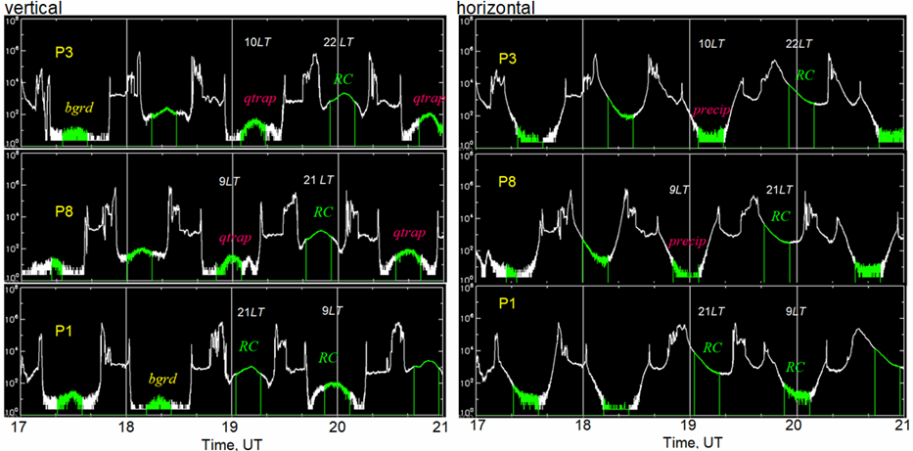
Figure 3. Time profile of protons fluxes with energies >30 keV measured by (left) vertical and (right) horizontal detectors at the beginning of the main phase during the superstorm on May 10, 2024. The equatorial passages are colored green. Equatorial measurements of quasi-trapped or precipitating protons are indicated respectively. The LEO satellites are: P1 – MetOp-1, P3 – MetOp-3, P8 – NOAA-18.

Discussion and summary
Thus, the current study shows why previous studies have had difficulty obtaining evidence for observation of injected protons simultaneously with electrons (FEE) [e.g., 5,7]. First of all, the fluxes of protons in the forbidden zone are overlapped with very intense fluxes of protons originated from the ring current, which is quickly developed on the main phase of magnetic storms. Another important reason for the failure to register >30 keV proton injections is effective losses of their energy in interaction with the neutral atmosphere [10].
The RC protons with energy >30 keV are characterized by high intensities of >10³ (cm² s sr)⁻¹ and populate mainly night and evening sectors in the beginning of main phase (Fig. 1 a,c). At that time, the ring current is asymmetric [e.g., 10]. In Fig. 1 (a,c) one can see intense proton fluxes at all latitudes in the longitudinal sector from 60°W to 60°E, which corresponds to evening regions. At low-to-middle latitudes those protons arrive to low altitudes as energetic neutral atoms after charge exchange interaction in the RC region, which is located at drift shells above L=2 [10]. At low altitudes, the energetic neutral atoms loss their electron and become ionized in interaction with the dense atmosphere. The neutral atoms are not guided by the magnetic field and, thus, they propagate in any direction and populate a wide range of latitudes. At middle-to-high latitudes, very intense (>10⁴ (cm² s sr)⁻¹) fluxes are produced by protons precipitating directly from the ring current region. At the early stage of the storm (18-20 UT), very intense fluxes of precipitating RC protons were observed in a limited range of longitudes, which indicates the asymmetry of the RC in the night-to-evening hours. With developing the main phase, the ring current becomes symmetric and occupies all local times as shown in Fig. 1 (b,d).
We show that the observed proton flux enhancements have different pitch-angle characteristics, indicating a local injection of protons from the inner RB in the pre-noon sector early in the storm main phase. We find that the injected quasi-trapped protons can be distinguished from the RC protons by their lower intensity and lack of enhancements of precipitating protons. This situation exists for a short time until RC becomes more symmetrical.
As one can see in Table 1, the FEE enhancements were observed simultaneously with the proton enhancements. It should be noted that being injected to low latitudes, electrons and protons drift in geomagnetic field in opposite directions – eastward and westward, respectively (Fig. 4). Hence, the injection region should be located somewhere eastward from the proton injection and westward from the electron injection. From comparison of Figs. 1 and 2 we can conclude that the injection region should have a spatial extension and it is located in the longitudinal sector from 120°E to 140°W. At 19 UT this sector corresponds to morning – prenoon local time. Moreover, the injection process should have a duration of the order of 20 min [4,6].
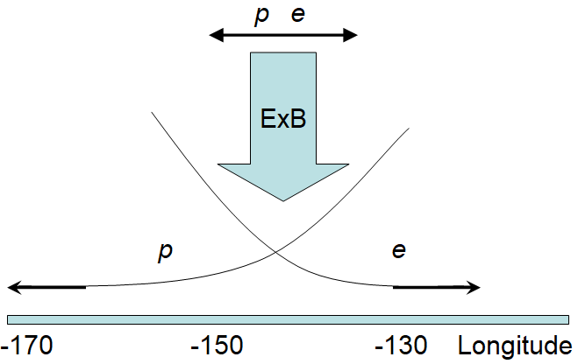
During the injection, protons continue drifting westward along the drift shells, which elevate to higher altitudes with decreasing longitude due to the asymmetry of the geomagnetic field. Hence, protons moving to higher altitudes become invisible for the satellite. In contrast, electrons drifting eastward move to lower altitudes and the satellite observes intense electron fluxes coming from higher L-shells with increasing longitude until the SAA region. This complex dynamic results in complicated pattern presented in Figs. 1 and 2. Therefore, we have shown that the injection of protons and electrons in the forbidden zone occurred above Pacific in the morning hours and
Figure 4. Schematic illustrating the physical mechanisms of electric drift (a radial transport of particles from the inner RB) and opposite azimuthal drift of energetic electrons and protons. | had the spatial scale of ~100° and temporal scale of ~20 min. This pattern supports the mechanism of radial transport of energetic particles from the inner radiation belt down to low altitudes due to E✕B or electric drift.
The origin of electric field in the inner magnetosphere at very low drift shells of L~1.2 is still unknown. In the studies [4,6] a possible external driver of the electric field for this FEE event was analyzed. It was shown that the magnetosphere was affected by a sharp negative jump of the solar wind pressure observed by Wind at ~18:45 UT. The pressure negative jump resulted in a decrease in SYM-H index at ~18:57 UT and a dayside expansion of the magnetosphere. It is important to note that during that time, the IMF Bz was positive. It meant that we can exclude magneto-plasma effects originated from interaction of IMF with the geomagnetic field. A solar wind pressure pulse results in generation of global inductive electric field in the Earth magnetosphere [8]. The magnetosphere expansion should result in generation of induced electric field, which is pointed westward in according to Faraday’s law. At low latitudes, where the geomagnetic field is pointed northward, this electric field causes radial E✕B drift of charged particles toward the Earth. The electrons and protons transport in the E✕B fields with the same rate. During the transport, they shift in opposite horizontal directions due to azimuthal drift: electrons – eastward and protons – westward. The divergence between electrons and protons depends on the rate of radial transport, which directly depends on the strength of inductive electric field. It was estimated that the electric field of 10 mV/m provides the transport from the lower edge of inner ERB (L=1.15) to L=1.1 within a reasonable time of ~20 min [4,6]. Hence the mechanism proposed can explain the dynamics of electron and proton enhancements in the forbidden zone.
Acknowledgments. The authors are grateful NOAA/POES/MetOp team for providing experimental data on energetic particles.
The study was carried out within the framework of the state assignment of Moscow State University named after M.V. Lomonosov.

References
1. Imhof W.L., Smith R.V. (1966). The behavior of trapped electrons and protons at the lower edge of the inner radiation belt. J. Geophys. Res., 71, 17, 4157-4170.
2. Voss H.D., Smith L.G. (1980) Global zone of energetic particles precipitation. J. Atmos. Terr. Phys., 42, 227-239.
3. Suvorova A.V. (2017). Flux enhancements of >30 keV electrons at low drift shells L <1.2 during last solar cycles, J. Geophys Res. Space Phys., 122, 12274-12287.
4. Suvorova A.V., Dmitriev A.V. (2025). On external drivers of sudden increase of energetic electrons in the quasi-trapped zone during superstorms. Geomag. Aeron., 65, No 6.
5. Suvorova A.V., Tsai L.-C., Dmitriev A.V. (2012). On relation between mid-latitude ionospheric ionization and quasi-trapped energetic electrons during 15 December 2006 magnetic storm. Planet. Space Sci., 60, 363-369.
6. Suvorova A.V., Dmitriev A.V. (2025). On the role of abrupt solar wind pressure changes in forbidden energetic electron enhancements. Universe, 11, 226.
7. Suvorova, A.V., Huang, C.-M., Matsumoto, H., et al. (2014). Low-latitude ionospheric effects of energetic electrons during a recurrent magnetic storm. J. Geophys. Res. Space Phys. 119, 9283−9302.
8. Ilie R., Daldorff L.K.S., Liemohn M.W., et al. (2017). Calculating the inductive electric field in the terrestrial magnetosphere. J. Geophys. Res., 122, 5391-5403.
9. Hui D., Vichare G. (2019). Variable responses of equatorial ionosphere during undershielding and overshielding conditions. J. Geophys. Res. Space Phys., 124, 1328–1342.
10. Søraas, F., Oksavik, K., Aarsnes, K., Evans, D., Greer, M. (2003), Storm time equatorial belt—An ‘‘image’’ of RC behavior. Geophys. Res. Lett., 30(2), 1052. https://doi.org/10.1029/2002GL015636.
Анализ потоков энергичных протонов под РПЗ на ранней стадии развития кольцевого тока во время геомагнитной супербури в мае 2024

А.В. Суворова

НИИЯФ МГУ, alla_suvorova@mail.ru

Аннотация.
Внезапное увеличение потоков энергичных (30–300 кэВ) электронов под кромкой внутреннего радиационного пояса Земли, известных как “запрещённые энергичные электроны” (FEE), изучается более 10 лет. Для объяснения этого явления был предложен механизм быстрого радиального переноса, суть которого заключается в электрическом дрейфе, независящем от знака заряда частицы. Оставляя пока в стороне вопросы, связанные с природой возникновения или проникновения электрического поля на столь низкие L-оболочки, следует отметить, что не удавалось обнаружить однозначных признаков увеличения потоков энергичных протонов. Ряд факторов мог повлиять на неудачи предыдущих исследований. В частности, инжектированные протоны и электроны дрейфуют в противоположных азимутальных направлениях, а во время главной фазы бури протоны кольцевого тока повсюду проникают на низкие высоты. В данной работе анализируются пространственно-временные характеристики увеличения интенсивности потоков протонов на ранней стадии магнитной бури в мае 2024 года, когда также наблюдалось FEE. Мы обнаружили доказательства инжекции протонов в этом событии, подтверждающие механизм электрического дрейфа.

