The Atmospheric Oxygen, Hydrogen and Helium Responses for the Extreme Geomagnetic Storm of 11 May 2024 over Different Regions
Lake Endeshaw^{1,2,3}
¹Department of Physics, Werabe University, P.O. Box 46, Werabe, Ethiopia
²Department of Space and Planetary Science, Entoto Observatory and Research Center, Space Science and Geospatial Institute, P.O. Box 33679, Addis Ababa, Ethiopia
³Department of Physics, Addis Ababa University, P.O. Box 1176, Addis Ababa, Ethiopia
Email: endeshawlake@gmail.com
ID: https://orcid.org/0000-0002-6400-9448
Abstract. Geomagnetic storms occur when the Earth’s magnetic field interacts with the magnetic fields of the solar wind. Geomagnetic storms have effects on the atmosphere, ionosphere, and magnetosphere. This study analyzes the response of the atmospheric parameters of atomic oxygen, hydrogen, and helium during the extreme magnetic storm of 11 May 2024. This storm was one of the most intense, with a minimum Dst value of -412 nT. The atmospheric oxygen, hydrogen and helium responses during the 11 May 2024 storm are studied by using the empirical atmospheric model of Naval Research Laboratory Mass Spectrometer Incoherent Scatter Extension 2002 (NRLMSISE 2.0) data measurements. To observe the atmospheric parameter responses for the storm, some days before and after the extreme storm day are used with latitudinal variability considerations. The results show that there were anomalies of atmospheric oxygen, hydrogen and helium that occurred some days before, after, and during the storm day of 11 May 2024. The atomic oxygen and helium are increased during the storm day, while the hydrogen is decreased during the main phase of the storm day. The atmospheric model of the NRLMSISE 2.0 responds to the anomalies of atmospheric parameters of atmospheric oxygen, hydrogen, and helium during the extreme magnetic storm on May 11, 2024.
Introduction
The Earth's atmosphere is a gaseous blanket that envelops the planet, keeping us warm and providing oxygen for us to breathe. The atomic oxygen is one of the element of Earth's atmosphere and it is very important in regulating photochemistry, energy balance, and dynamical movements in the Earth's mesosphere and lower thermosphere, and it is also challenging in the applications of the higher atmosphere [1]. Atomic hydrogen (H) is one of the most abundant elements in our universe, and it is another important element in the atmosphere [14]. An other important component in the lower exosphere is the atmospheric helium. Helium in the atmosphere of the Earth represents the dynamic processes that transfer heat energy and the amount of mass [2]. The changes in the atmospheric atomic abundances during geomagnetic storm times are due to the energy and particle precipitation of the structure, dynamics, and generally the chemistry of the atmospheric temperature and pressure gradients [3]. At the time of geomagnetic activity, especially during super geomagnetic storms, significant thermosphere disturbances occur with extraordinarily quick variations. These events are characterized by great increases in temperature and density, significant changes in neutral composition, and the production of high-speed wind flows and wide-amplitude waves that may impact the entire world [4]. The influence of the geomagnetic storm on the atmosphere is explored by using different measurement techniques. One of the most well-known empirical atmospheric models is the NRLMSISE model [5]. The present study will look at the influence of extreme geomagnetic storms on the atmosphere that occurred on 11 May 2024. The current study aims to evaluate the latitudinal and daily responses of atmospheric oxygen, hydrogen, and helium that occurred a few days before, after, and during the extreme geomagnetic storm day of 11 May 2024.
Data and Method of Analysis
In this study, we analyze the responses of atomic oxygen (O), atomic hydrogen (H), and helium (He) by using the NRLMSISE 2.0 model in different regions. For the three atmospheric parameters, the hourly selected latitudinal variability with constant longitudes of (0°N, 30°E), (30°N, 30°E), (60°N, 30°E), (90°N, 30°E), (30°S, 30°E), (-60°S, 30°E), and (-90°S, 30°E) is considered to assess the consistency of the model on the geomagnetic storm based on the atmospheric parameter anomalies from May 9 to 14, 2024. The NRLMSISE model is an empirical model, so it is based on measured data using solar activity and geomagnetic activity observations. This model takes real observations into consideration, making its measurements more precise [6]. The NRLMSISE 2.0 model data are publicly available online at https://ccmc.gsfc.nasa.gov/models/NRLMSIS~2.0/. The May 2024 storm, known as the Mother's Day storm, peaked at -412 nT, impacting modern-day technology that is vulnerable to space weather hazards with relatively few sub-storm traces throughout the recovery period. In this study, the extreme geomagnetic storm of (G5 class level) that occurred on May 11, 2024, with a minimum value of Dst index -412 nT and Kp = 9, was considered to study the anomalies of atomic oxygen (O), atomic hydrogen (H), and helium (He) , by using the NRLMSISE 2.0 model. The geomagnetic indexes are downloaded from the Omniweb website (https://omniweb.gsfc.nasa.gov/form/dx1.html).
Results and Discussions
Figure 1 shows the response of atmospheric parameters of atomic oxygen (left side), hydrogen (middle), and helium (right side) in latitudinal variability (low latitude, middle latitude, and higher latitude) with constant longitudes from the days May 9 to May 14, 2024 in the Northern Hemisphere. The response of atmospheric oxygen for the geomagnetic storm (Figure 1a-d) shows clear latitudinal variability, with an increase in near the equatorial region and a decrease near the northern pole during the day of May 11, 2024. The atomic hydrogen response for the geomagnetic storm (Figure 1e-h) shows a high decrease near the equatorial region and low effects near the northern pole during the day of May 11, 2024. The response of helium variability for the geomagnetic storm (Figure 1i-l) shows clear latitudinal variability with an increase in near the equatorial region and a decrease near the northern pole during the day of May 11, 2024 in the Northern Hemisphere.
Figure 2 presents the hourly variability of geomagnetic indices (a) and response of atmospheric parameters of atomic oxygen (Figure 2b-d), hydrogen (Figure 2e-g), and helium (Figure 2h-j) in latitudinal variability (middle and higher latitudes) from the days May 9 to May 14, 2024 in the Southern Hemisphere. The response of atmospheric oxygen in the Southern Hemisphere for the geomagnetic storm (Figure 2b-d) shows clear latitudinal variability of an increase on May 11, 2024, at (-30o, 30o), a slight decrease at (-60o, 30o) and a complete decrease at (-90o, 30o). The response of atmospheric hydrogen in the Southern Hemisphere for the geomagnetic storm (Figure 2e-g) shows completely decreased values on May 11, 2024, than on other days at all latitudes. The response of atmospheric helium in the Southern Hemisphere for the geomagnetic storm (Figure 2h-j) shows clear latitudinal variability of with mostly increase on May 11, 2024 at (-30o, 30o) and decrease at (-60o, 30o) and (-90o, 30o) latitudes.
Conclusions
Geomagnetic storms are one of the most natural hazards that affect the hourly and latitudinal variation of atmospheric parameters. This study considers the effect of an extreme geomagnetic storm on May 11, 2024, with a minimum value of Dst -412 nT on the atmospheric parameters of oxygen, hydrogen, and helium. The empirical atmospheric model of Naval Research Laboratory Mass Spectrometer Incoherent Scatter Extension 2002 (NRLMSISE 2.0) data analysis is used to study the atmospheric oxygen, hydrogen, and helium responses during the storm on May 11, 2024. The response of the atmospheric parameters of oxygen, hydrogen, and helium for the geomagnetic storm shows clear latitudinal variability, with an increase near the equatorial region and a decrease near the regions of the poles during the day of May 11, 2024. During the storm day, the atmospheric parameters of oxygen, hydrogen, and helium show a clear hourly and latitudinal variation compared to the non-disturbed days of May 2024. During the storm day, atomic oxygen and helium concentrations rise, while hydrogen concentrations fall. The NRLMSISE-2.0 atmospheric model captures atmospheric oxygen, hydrogen, and helium anomalies during the extreme magnetic storm on May 11, 2024.

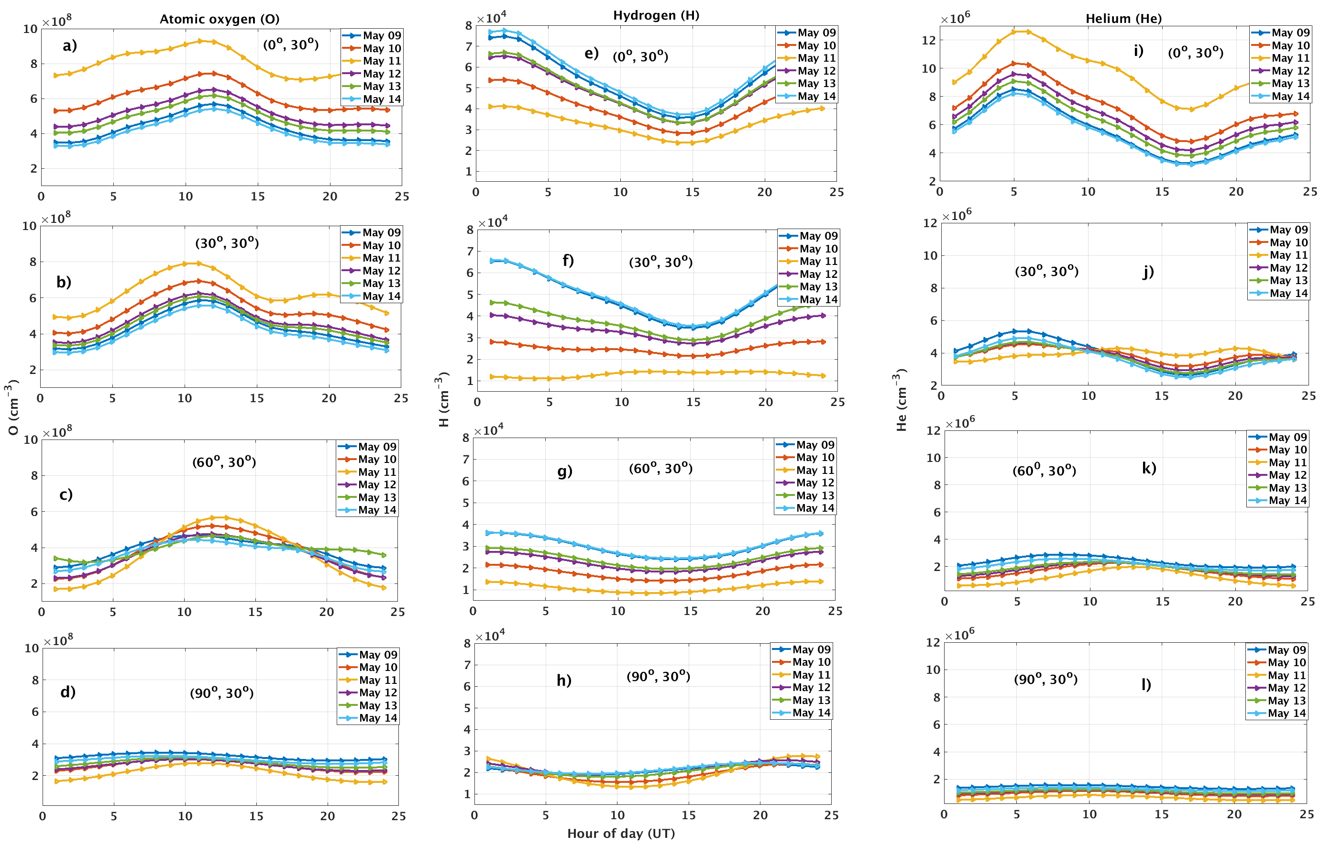
Figure 1 The hourly geomagnetic storm response of atmospheric parameters of atomic oxygen (left side), hydrogen (middle), and helium (right side) in low, middle, and higher latitudes with constant longitude from the days May 9 to May 14, 2024 in the Northern Hemisphere.

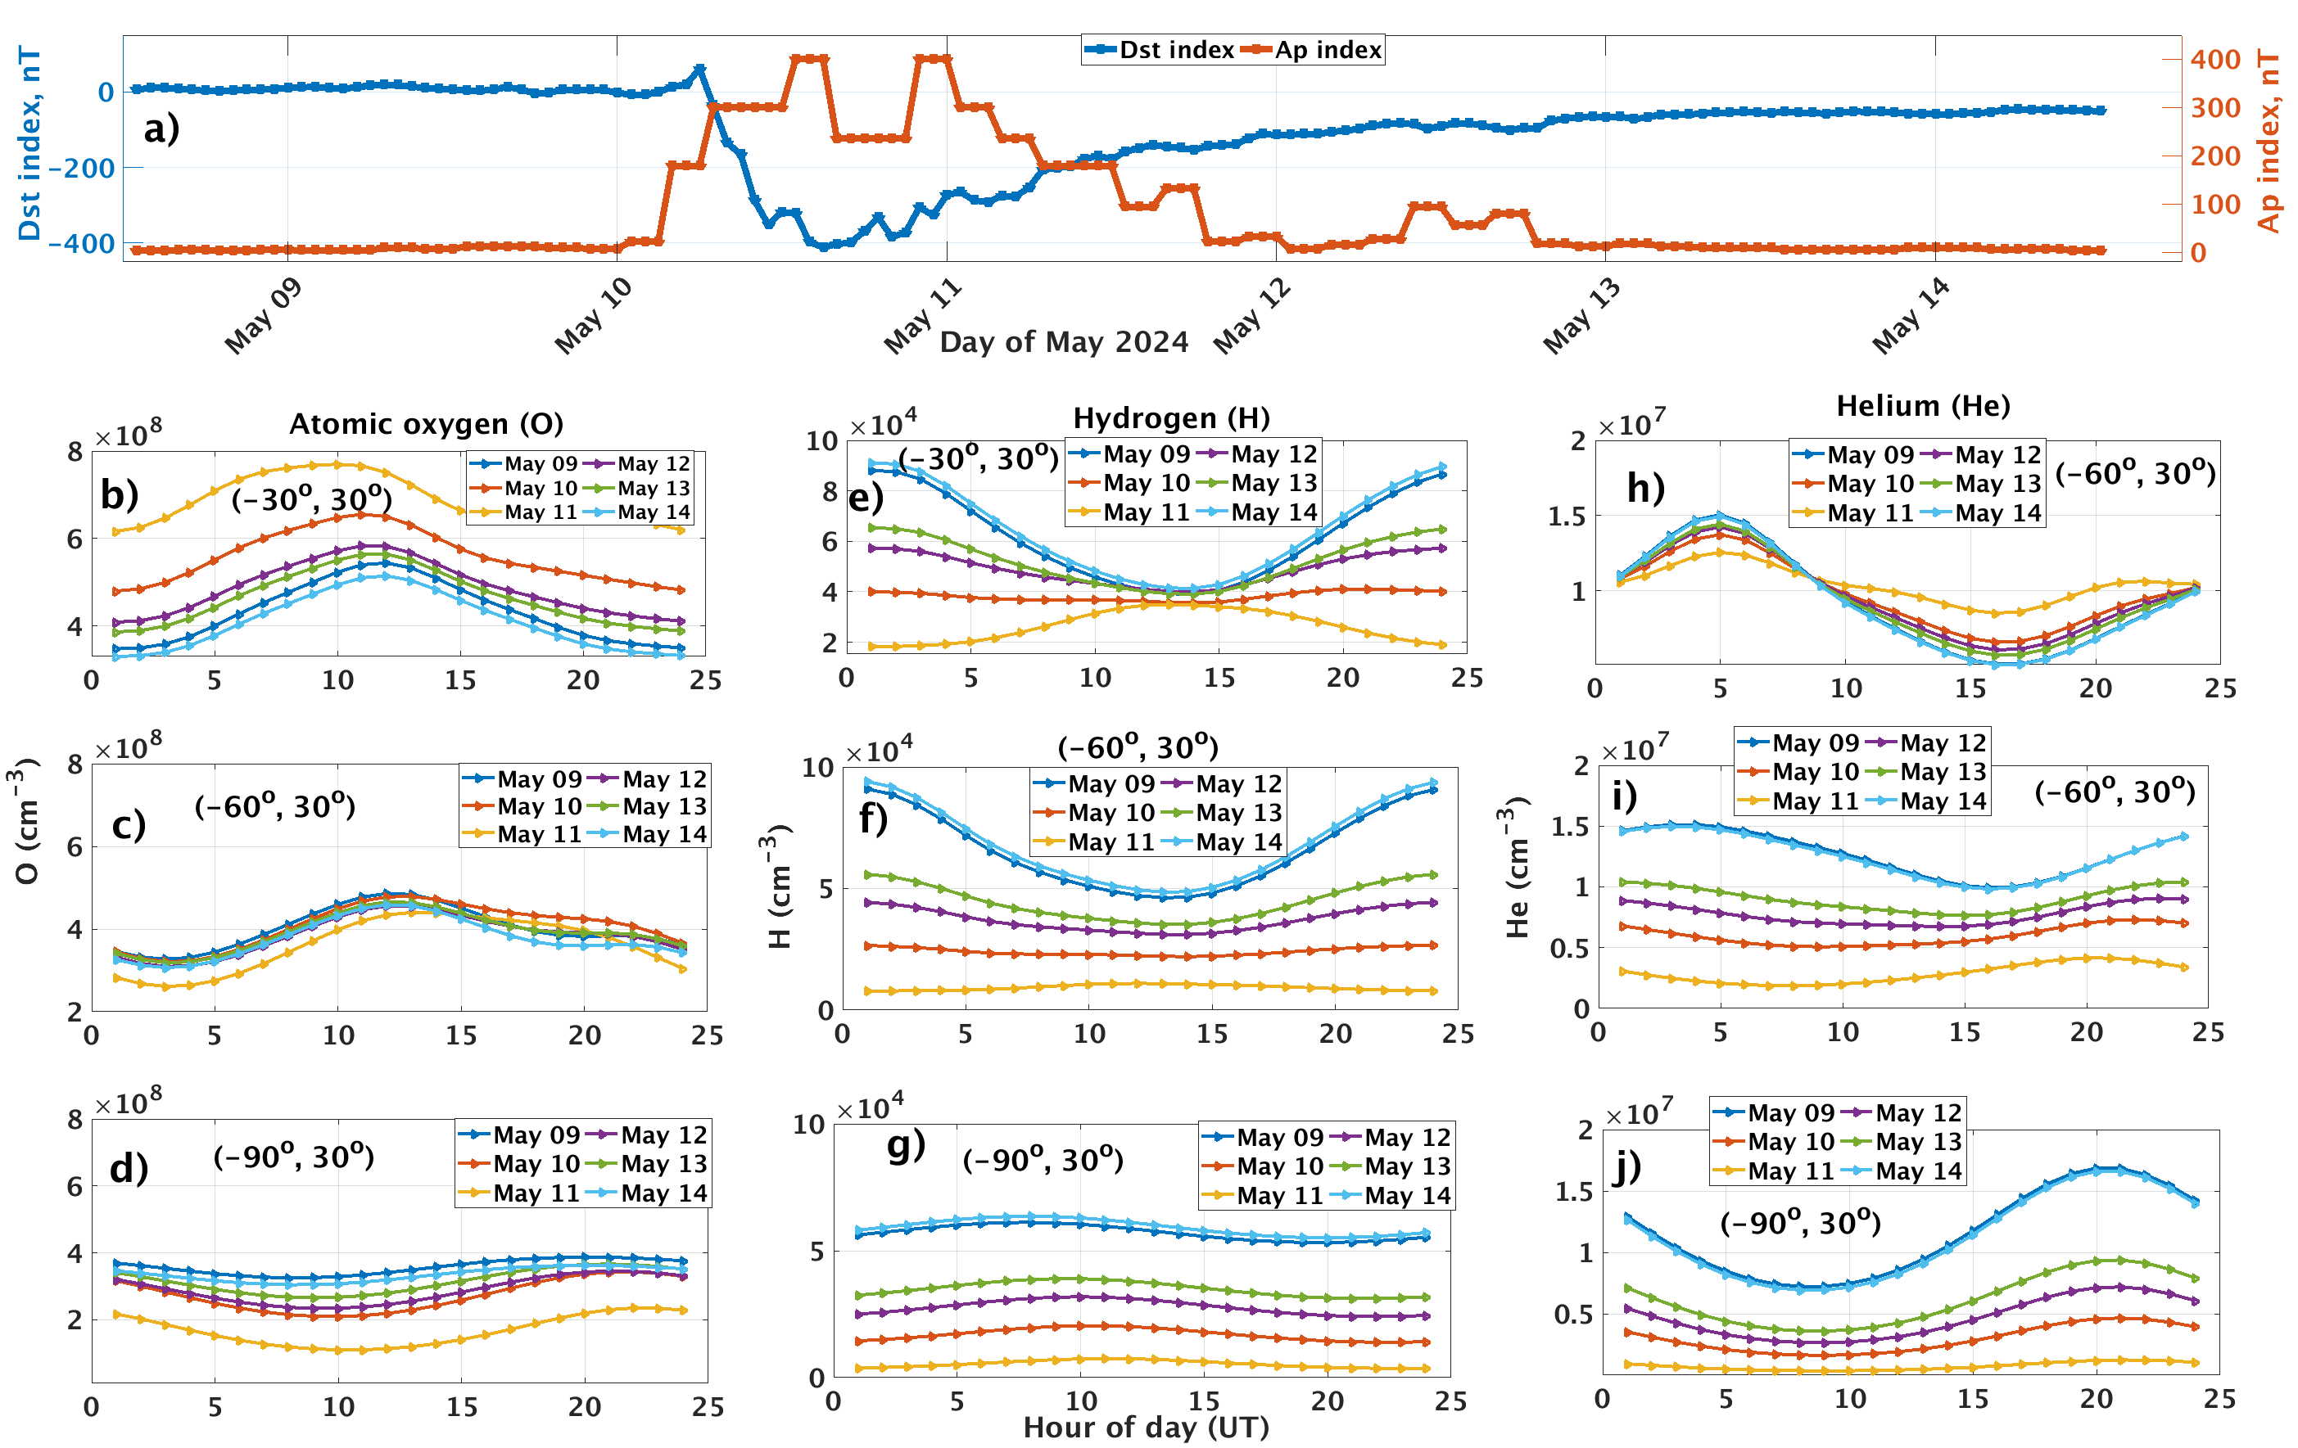
Figure 2 The hourly variability of geomagnetic indices (Ap and Dst) (a) and geomagnetic storm response of atmospheric parameters of atomic oxygen (b-d) (left side), hydrogen (e-g) (middle), and helium (h-j) (right side) in middle and higher latitudes with constant longitude from the days May 9 to May 14, 2024 in the Southern Hemisphere.
Acknowledgments
The authors kindly acknowledge the NRLMSISE 2.0 model developer, which is freely available online on the website: https://ccmc.gsfc.nasa.gov/models/NRLMSIS~2.0/. The geomagnetic indexes are downloaded from the Omniweb website (https://omniweb.gsfc.nasa.gov/form/dx1.html).
References
- Shao, L., Xie, G., Zhang, C., Liu, X., Lu, W., He, G., & Huang, J. (2020) Metals, 10(1), 128,
- Kotov D and Bogomaz O. (2023) Front. Astron. Space Sci.; 10:1200959, https://doi.org/10.3389/fspas.2023.1200959.
- Kockarts G. (1973) Space Sci Rev. 14, 723–757 . https://doi.org/10.1007/BF00224775
- Fuller‐Rowell, T. J., Codrescu, M. V., Moffett, R. J., Quegan, S. (1994) Journal of Geophysical Research: Space Physics, 99(A3), 3893-3914, https://doi.org/10.1029/93JA02015
- Rees, D. (1995) Journal of Atmospheric and Terrestrial Physics, 57(12), 1433-1457, https://doi.org/10.1016/0021-9169(94)00142-B
- Emmert, J. T., Jones, M. Jr., Siskind, D. E., Drob, D. P., Picone, J. M., Stevens, M. H., et al. (2022) Journal of Geophysical Research: Space Physics, 127, e2022JA030896. https://doi.org/10.1029/2022JA030896

