Position of the primordial release of solar flare energy at the extended surface of magnetic lines with increased current density: Results of MHD simulation

А.I. Podgorny¹, I.M. Podgorny²

¹Lebedev Physical Institute RAS, Moscow, Russia, podgorny@lebedev.ru
²Institute of Astronomy RAS, Moscow, Russia, podgorny@inasan.ru

The study of the extended surface of magnetic lines with increased current density, having the form of an arcade, is continued. The appearance of such a surface, apparently, can solve the problem of the coincidence of the positions of flares found from the results of MHD simulation with the observed positions of flares, which are bright regions of flare emission.
According to the existing concepts, during a solar flare, the energy of the magnetic field of the current sheet formed as a result of the accumulation of disturbances in the vicinity of a singular line of the X-type magnetic field is released. It is quite difficult to determine the possibility of a flare and its position based on the MHD simulation results due to the complexity of the magnetic field configuration in the corona. The field is highly tangled, a diverging magnetic field can be imposed on the X-type configuration, so it is almost impossible to directly determine the position of the singular line based on the type of magnetic field obtained as a result of MHD simulation, even if a current sheet begins to appear or has already formed in its vicinity. For this purpose, a graphical system for searching for flare positions was created, based on searching for current density maxima and studying magnetic field configurations in their vicinity. It is assumed that the absolute value of the current density reaches a maximum in the center of the current sheet. However, as the analysis of the calculated field showed, this assumption is not always fulfilled. Therefore, although the developed system is useful for analyzing complex magnetic field configurations, its direct use often does not provide an opportunity to correctly determine the positions of flares.

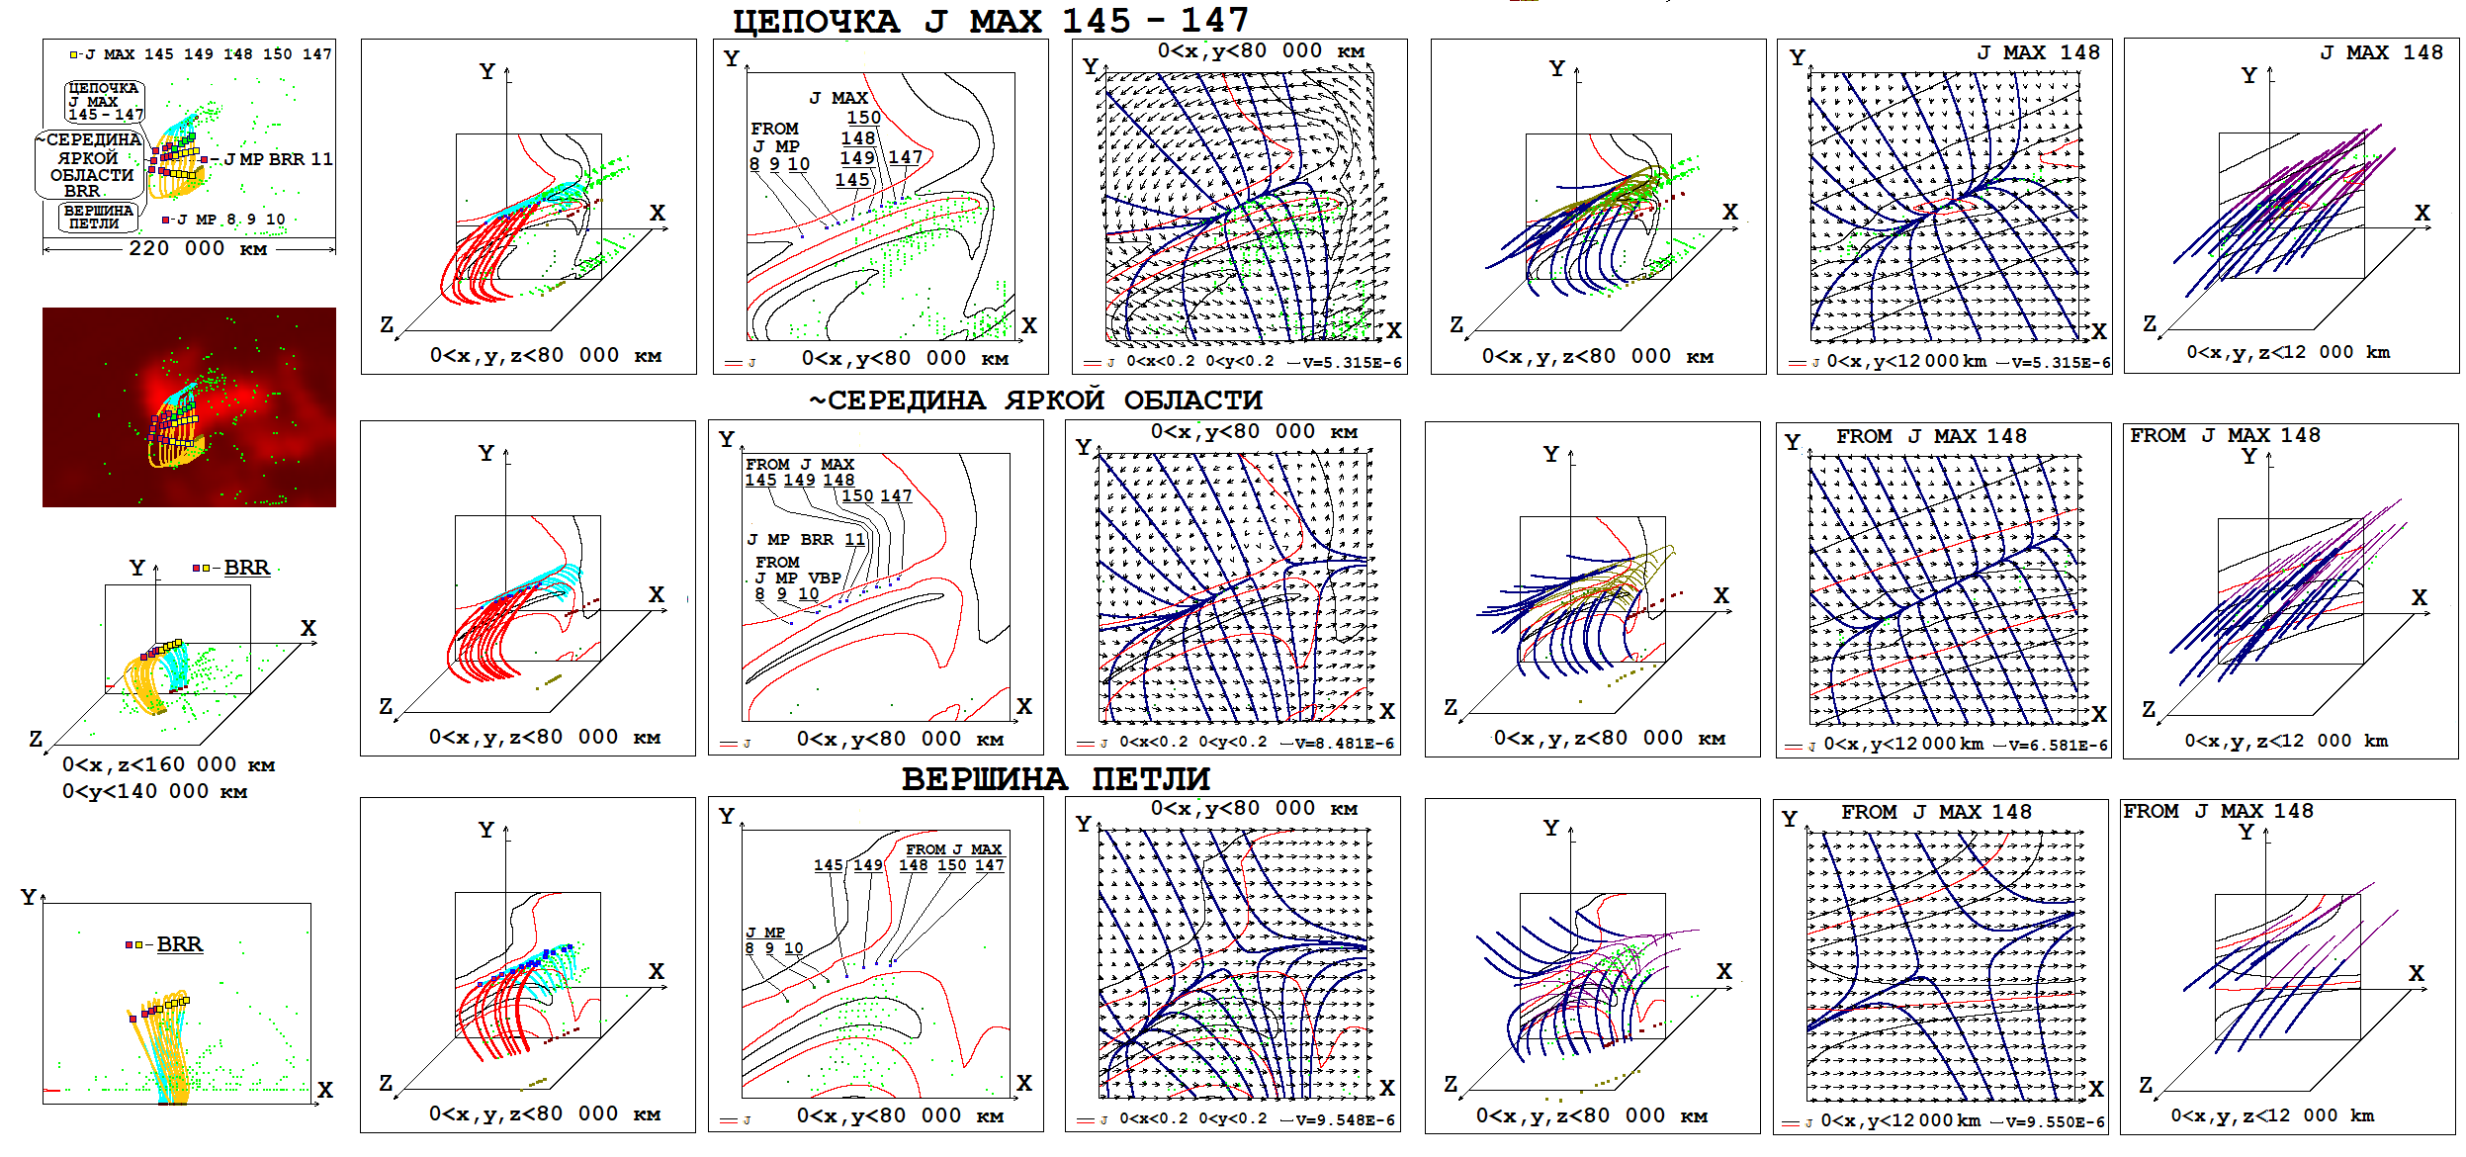
To study the possibility and locations of flare instability, an analysis of magnetic field configurations in areas with centers at different points of the arcade was performed. These configurations, as well as the location of the arcade surface in space and on the solar disk, are shown in the figure. The analysis shows that the conditions determined by the magnetic field configuration are better promoted to the development of flare instability not at the location of the maximum current density, but at the top of the arch, where in a planе configuration the X-type magnetic field dominates over the divergent magnetic field.

